**Mule Soft Project**

**1.What is Mule Soft?**

1. Mule is a Runtime Environment for AnyPoint Platform and it is Java Based ESB.

**It is a Integration Platform that allows:**

1. Developers to connect applications together and Exchange the data Quickly and Easily.
2. Also it integrates the Existing Systems regardless of Technology’s that uses JMS,WebServices,DataBase,HTTP and Other
3. Systems like SalesForce,SAP,Cloud System …etc.

**2.Why Mule Soft?**

**1.Development Environment**

* easy-to-use development environment is extremely important in order to increase productivity and lower development cost.
* MuleSoft provides a development environment called Mule Studio, which is based on Eclipse.
* It integrates with other commonly used tools such as Maven and GitHub.
* Using Mule Studio you can develop your use-cases/flows with a graphical drag-and-drop editor (or edit the flow’s XML file if you insist).
* You can select all of the different components that you may need in your flow and configure them in an easy-to-use way

**2. Out-of-the-box Features**

* Mulesoft provides 100’s of components that come built-in with Mule Studio.
* Message Sources – endpoints - HTTP, FTP, TCP, File, Database…
* Message Processors - Components – REST, SOAP, JavaScript, Java, Python…
* Filters
* Routers – Choice, Scatter Gather
* Scopes –for-each, Cache,Try,Until Successful,Asyncronus
* Transformers – Built-in transformers - convert XML, JSON, File, Byte Array, Object, String ..etc
* Dynamic transformer – AnypointDataMapper dynamically converts between flat (CSV, fixed-width file, Excel)and structured (XML, JSON, POJO objects, key-value maps) formats.
* Connectors – Amazon, Facebook, Google products, Sharepoint, MongoDB, Salesforce and Twitter to name a few.

3.**Open-source:**

* Mulesoft’s components and features are easily extended, and in case you didn’t find a connector you need (for example) you can develop one.

**3.Benifits of MuleSoft?**

1. The power of Mule runtime engine, hosted and managed in the cloud. CloudHub is the platform as a service (PaaS) component of Anypoint Platform .
2. It is a fully-managed, multi-tenanted, secure, and highly available platform for APIs and integrations.

**4.Features of Mule Soft?**

1. Orchestrate : No coding and only the connectors will fulfill the requirement to Connect db,SAP ,Salesfore,Cloud services with some configuration.
2. Transformations: It is like data transformation from one format to another like XML to Json using some Language like DataWeive
3. Enrichments:Suppose we have first name as Ravi kumar and 2nd name as Thirumala from Source and then Target System is required like Full name as one field then we concate FN+LN and send to Target.

**5.Drawbackes of MuleSoft?**

1. RAML should be designed and compiled within the Anypoint studio.
2. It is a verry costly and small organizations cannot use it
3. When we write Dataweave Expression and if that is wrong then it shows previous out .
4. Sometimes we have to write xml because the graphical designer of flows is not responsive.

**6.What is the Architecture Mule Esb Follows?**

1. Micro Services. API LED Connectivity

**7.What is Mono Lithic and Microservices Architecture?**

1. If all the functionalities of a project exists in a single codebase, then that application is known as monolithic application.

**Disadvantages:**

* It is too large in size and difficult to manage.
* If there is any small change then need to request for Downtime for all the functionalities.
* If the file size is large then it will take time to deploy.
* If any new joiners joined and they have recruited for specific Module then they need to understand whole project.
* It is not reliable.

**Advantages:**

* The problems of network latency and security are relatively less in comparison to microservices architecture.
* Easier to deploy as only a single jar/war file is deployed.

1. Micro services are the small services that work together to fulfill requirement.

**Advantages:**

* **Single responsibility**: For each and every individual Functionality we can create one microservice.
* **Reliable or Design for failure :** If one Functionality is down then it will affect for only that module and others will work As expected
* **Built around business capabilities:** each microservice can use different technology based on business requirements
* Easy to deploy
* Technology Independent
* Easy to scale.
* If there is any change in one microservice then we can deploy only that.

**Disadvantages:**

* If micro services are more then difficult to manage [Maintanance is difficult].
* Need to get much skilled developers for microservices development
* Debugging is difficult as the control flows over many microservices
* Microservices are costly in terms of network usage as they need to interact with each other and all these

Remote calls results into network latency.

**8.What is API LED Connectivity and what are S-API,P-API,E-API?**

1. The Methodology that transfer data b/w application reusable and purposeful API’s

* **System API:** This API is Reusable and it can be built for specific Functionality. It can be used by multiple Projects
* **Process API :** This API is Combination of system APi’s as per the business and consumed by Experience API’s.
* **Experience API:** This API are created to consume by end Users or Systems.

**9.How you have designed your api’s in your project?**

1. We will use anypoint platform to design the Services Using RAML [Restful API Modeling Language]
2. Yes I have done Vehicle Create,Delete,Get,Update
3. GetMarkets,ServiceConversion,vehicleAssosiation
4. getGeofenceDetails,DeleteGofenceAssosiation,CreateGeofence,UpdateGeofence
5. CreateDriver,DeleteDriver,AssignDriverToVehicle
6. getDTCInfo,UpdateDTC,DeletDTC

**Below URL will give clear idea About Design:**

<https://www.youtube.com/watch?v=nef3G3awxKI&ab_channel=sivathankamanee>

<https://www.youtube.com/watch?v=6Cq3APBYHwM&ab_channel=sivathankamanee>

**10.What are the tools we use for MuleSoft?**

1. AnyPointFlatform,AnyPointStudio,Java 8,PostMan,SOAP UI,AMQ,DataBases

**11.Explain about AnyPoint Platform?**

1. We can Design,Exchange,Mange and Deploy using Any Point PlatForm.

**12.Explain about AnyPoint Studio?**

1. It is an IDE and it is used for development of Mule ESB.It contains Canwas,Pallet,Console … etc.
2. Is has 100’s of inbuilt Connectors,Adoptors,Components and it can support for Connectors Customizing also.

**13.What is Flow,PrivateFlow,Sub Flow?**

1. Flow : It contains Source,Process and Error Handling.
2. Private Flow : It contains Source ,Process and Error Handling but if we are not keeping any Source then we will call Private Flow
3. Sub Flow : It contains only Process.We can add try block Here.Also If Error is not handled then it will forward to Calling Flow.

**14.What is Flow Reference?**

1. It is used to call sub or private flow from main flow.
2. In Configuration it shows all the Sub or Private flows.
3. If wont select any sub or Private flow then it will fails the deployment.

**15. What is Mule Message Structure?**

1. It contains Mule Event[ message[Payload, Attributes] and Variables].

**16.What is the Payload in Mule?**

1. It is Actual message content and it can be overridden from One Component to Other. Payload can be a Literal String or Data Weave Expression( #[“Hellow World”])

**17.What are the types of Variables in Mule?**

1. Variables are used to Store Data for further use in Flow and it will be available until the flow ends.

**18.What are attributes? What is the scope of Attributes?**

1. Attributes provides Metadata Such as queryParams,File Size … Etc.These are Immutable.
2. We can access Attributes using *#[attributes.queryParameters.name]*

**19.How to set Variable in Mule?**

1. Drag the setVariable Component from Mule Pallet to Canvas and set the Variable Name and Content.
2. We can access Variables *vars.name*

**20.What is Transform Message in Mule? Why is it used for?**

1. It is used for changing the request payload from an Endpoint before being sent to the Flow from XML to JSON and JSON to XMl …etc
2. Also we can set the variables and Attributes in Transformer.
3. We can enrich the data from input using data Weave language and forward to next component in the flow.

**21.what are routers we have in MuleSoft?**

APIKITRouter, Choice and Scatter-Gather routers.

**22.What is MEL? How to access Payload, Attributes and Variables?**

MEL is a lightweight, Mule-specific expression language that you can use to access and evaluate the data in the payload, properties and variables of a Mule message.

* *#[payload]*
* *#[message.inboundProperties.'propertyName']*
* *#[payload.methodCall(parameters)]*
* *#[xpath3('//root/element1')]*
* *#[payload.age > 21]*
* *#[message.inboundProperties.'locale' == 'en_us']*
* *#[flowVars.output]*

**23.What is Data Weave Language[DWL]?How to access Payload, Attributes and Variables?**

1. DataWeave is a programming language designed for transforming data.
2. You write modules and mapping files in a DataWeave Language (. dwl) file and import into your Mule app through DataWeave scripts in Mule components. Both modules and mapping files are useful when you need to reuse the same functionality or feature over and over again.
3. The $ symbol can be used for accessing the value of a key-value pair in a map.
4. $$ can be used for getting the key (or index)
5. There are predefined functions provided in DWL : map,mapObject,flatMap,fluck,reduce,flatten …etc.
6. 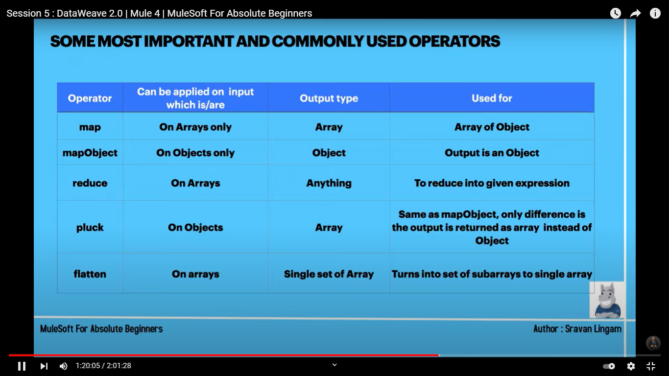

**24.What is lookup function in DWL?**

Lookup function is used for calling the sub or private from main flow using DWL.

**25. Have u faced Cannot Coerce Null?**

Yes when we will get the input String as null while assigning to other variable to field then we can get this error.

We can avoid this error using for

1. name : name we can write name:name as String default “”;
2. Id:id as id:id as Integer default 0;
3. status:status as Boolean default false;

**26.How do u deals with dates ?**

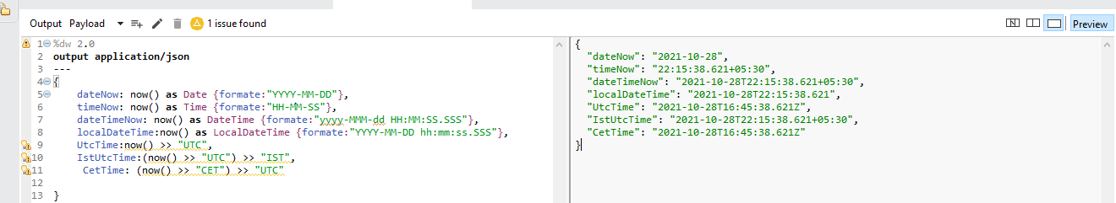

**26. How to create pagination ?**

[**https://apisero.com/implementing-pagination-using-offset-limit-in-database/**](https://apisero.com/implementing-pagination-using-offset-limit-in-database/)

**27.What are the Connectors used for Database ?**

We have Insert,Update,delete,select,Bulkupdate,bulkDelete,bulkinsert,Execute Script,Execute DDL Statement,Stored Procedure call

**28.Steps to connect to DB?**

1. Goto Connector Configuration
2. Connection = Mysql or Oracle
3. Required Library = Add Jar
4. Host,port,un,pw,db
5. Add the Query and parameters

**28.How to maintain LOCAL transactions while connecting DB?**

Transaction Management Using Try – In this use case you will learn how to handle the transaction using try block (either all success or all failure)

We need to store the data to 2 tables 1. Customers and 2.Address .

Drag try component first and then drag 2 Bulk insert components for A Customer and Address inserts

Below settings need to do

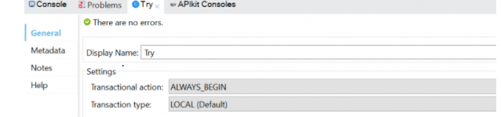

Select the Bulk Insert Operation and Go to Advanced tab and configure the Transaction Action as **ALWAYS_JOIN.**

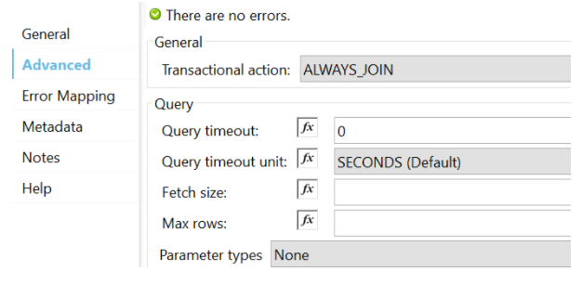

1. If any failure while Insert to DB then No record will stored in DB
2. We need to Select Isolation Properties when we are going for transaction like below. Why because by default it will be Locking whole table but in Real time that is not good. We have different Isolation Properties and we can select as per our Requirement.

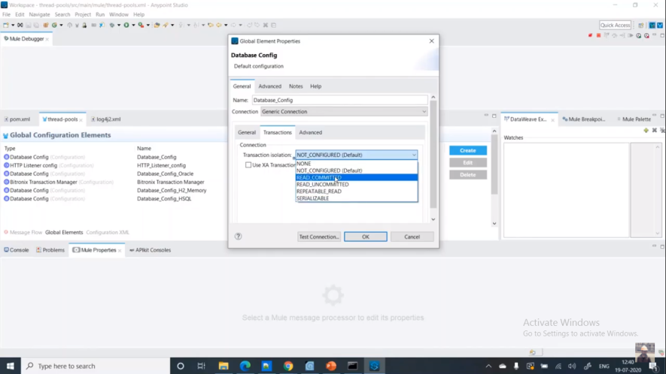

**Read Uncommitted** – Read Uncommitted is the lowest isolation level. In this level, one transaction may read not yet committed changes made by other transaction, thereby allowing dirty reads. In this level, transactions are not isolated from each other.

**Read Committed** – This isolation level guarantees that any data read is committed at the moment it is read. Thus it does not allows dirty read. The transaction holds a read or write lock on the current row, and thus prevent other transactions from reading, updating or deleting it.

**Repeatable Read** – This is the most restrictive isolation level. The transaction holds read locks on all rows it references and writes locks on all rows it inserts, updates, or deletes. Since other transaction cannot read, update or delete these rows, consequently it avoids non-repeatable read.

**Serializable** – This is the Highest isolation level. A serializable execution is guaranteed to be serializable. Serializable execution is defined to be an execution of operations in which concurrently executing transactions appears to be serially executing.

Enable logs:

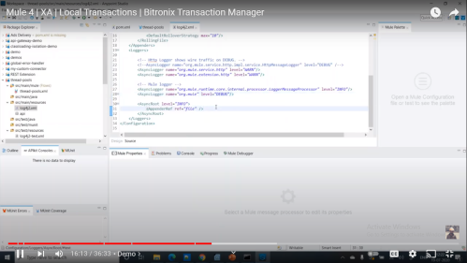

**28.How to handle XA Transactions in Mule ?**

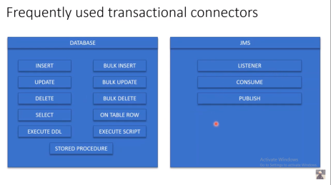

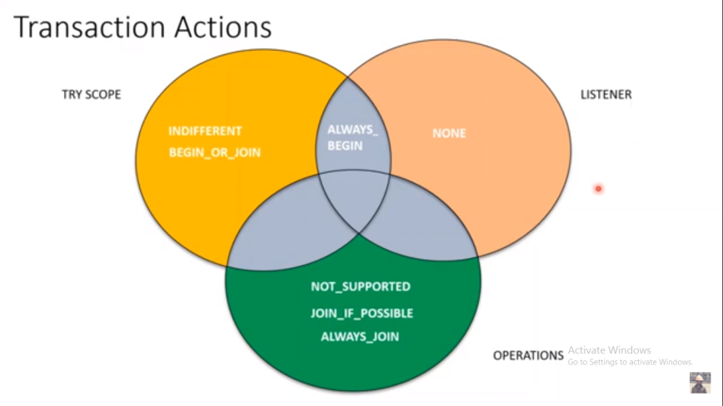

How the Transaction flow will happens in the Flow Diagram.

**HTTP Listener:**

1.In Mule 4 above we have merged the CPU_LITE,CPU_INTENSIVE,BLOCKING_IO as Oobha ThreadPool.

2.If we receive any request to Listener then SHARED_GRIZZLY will take it and The handover from Listener to Actual Mule Flow will done by CPU_LITE.

3.After that BLOCKING_IO will take care of whole flow or transaction Execution

4.After that the Response will taken care by DEDICATED_GRIZZlY.

5.Fillay CPU_LITE will give the Response to Listener

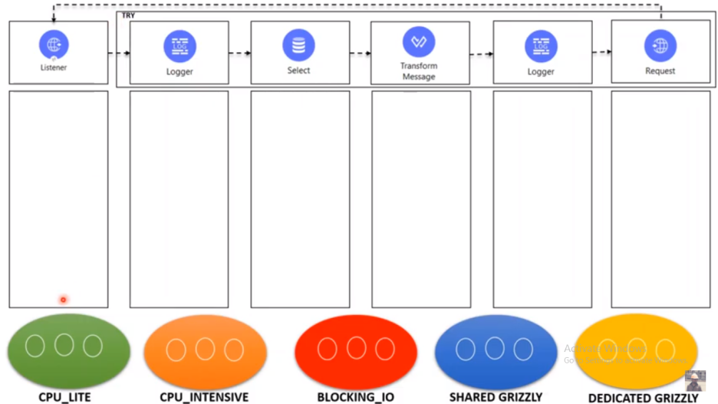

JMS Listener:

There are no CPU_LITE,CPU_INTENSIVE here directly BLOCKING_IO will Take care of Flow or transaction

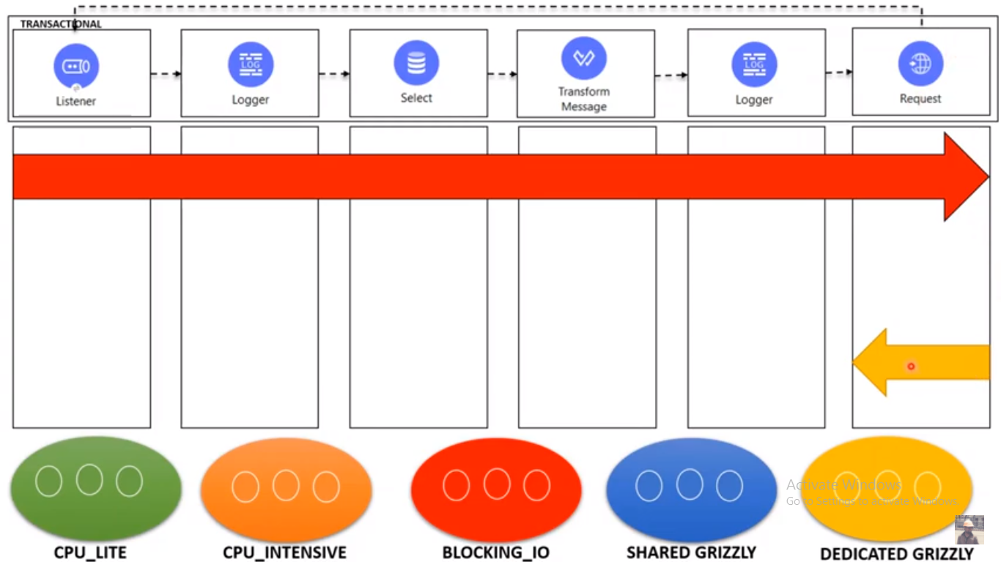

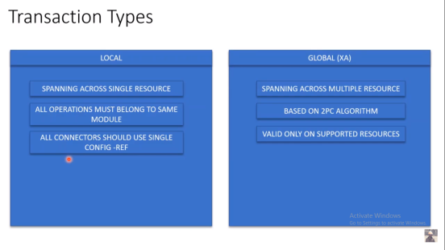

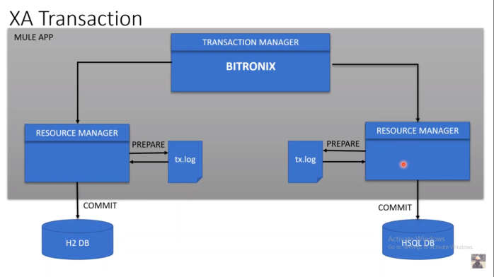

Step 1: In Try we need to select

Transaction Action : ALWAYS_BEGIN

Transaction Type : XA

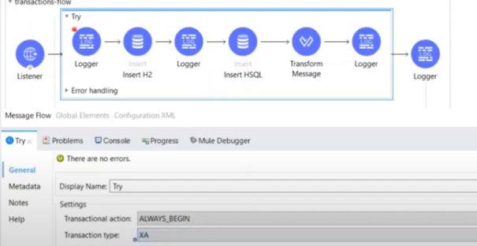

Step 2 : We should do the below for 2 DB components. H2 and HSQl

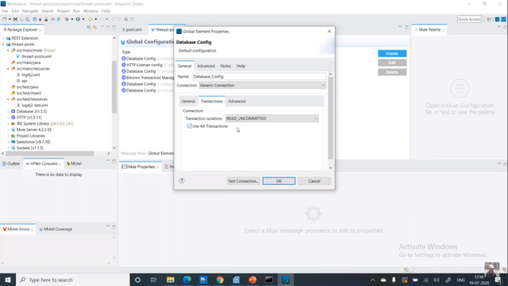

Step 3 : Need to add BITRONIX Transaction manager

No Configurations required we just need to add the BITRONIX

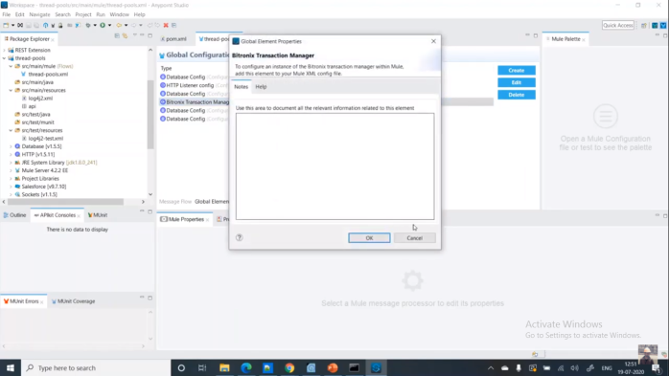

Explanation:Once we run the Application then we can see the logs for how the BITRONIX will handle the XA Transaction.

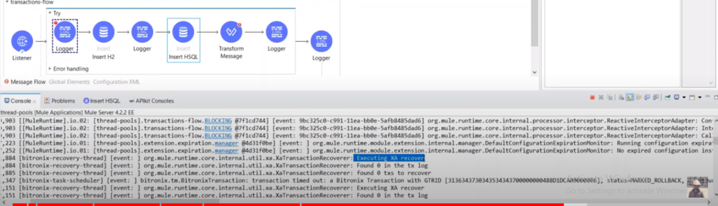

It will check xt.log file if there are any logs to rollback.

We can see the TX files under the Mule .Home:

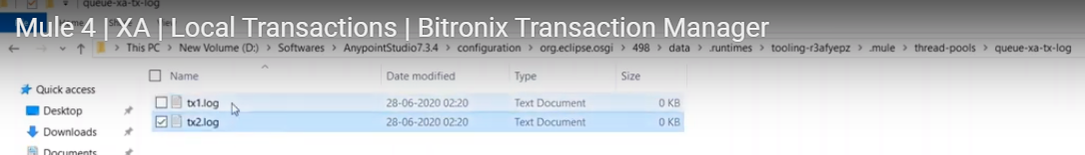

**28.How to call Stored Procedures in Mule?**

1. Connect to DB.
2. Create Stored Procedure.

*create or replace PROCEDURE add_job_history*

*p_emp_id job_history.employee_id%type*

*, p_start_date job_history.start_date%type*

*, p_end_date job_history.end_date%type*

*, p_job_id job_history.job_id%type, p_department_id job_history.department_id%type)*

*IS*

*BEGIN*

*INSERT INTO job_history (employee_id, start_date, end_date,_id, department_id)*

VALUES(p_emp_id, p_start_date, p_end_date, p_job_id, p_department_id);

END add_job_history;

1. Drag the Stored Procedure Connector from Mule Pallet to Canwas
2. Call the stored Procedure like below:

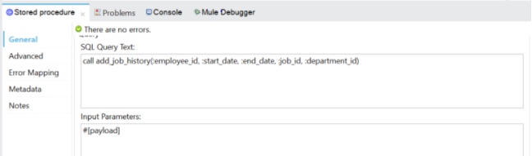

**29.How to do Transaction in JMS?**

We can Active Transaction in JMS and we can post same message to 2 queues and if both Queues received the messages Successfully then only we will commit the message or we will rollback the message from both queues.

We can do the Transaction same like BD .

ALWAYS_BEGINS:It will always begin New Transaction

JOIN_ALWAYS : If there is a Transaction then joins or Throws exception

JOIN_IF_POSSIBLE : If there is a trasaction then Join or continue without transaction

BEGIN_OR_JOIN : If there is a Transaction then join or Begin new Transaction

**29.How to Handling Persistent/Guaranteed Delivery in JMS?**

When we are publishing/Listening the message we need to do the Below configuration to send the failure message to DLQ.

Persistence Delivery = TRUE

Time To live = 1

Time to Live Until = DAY

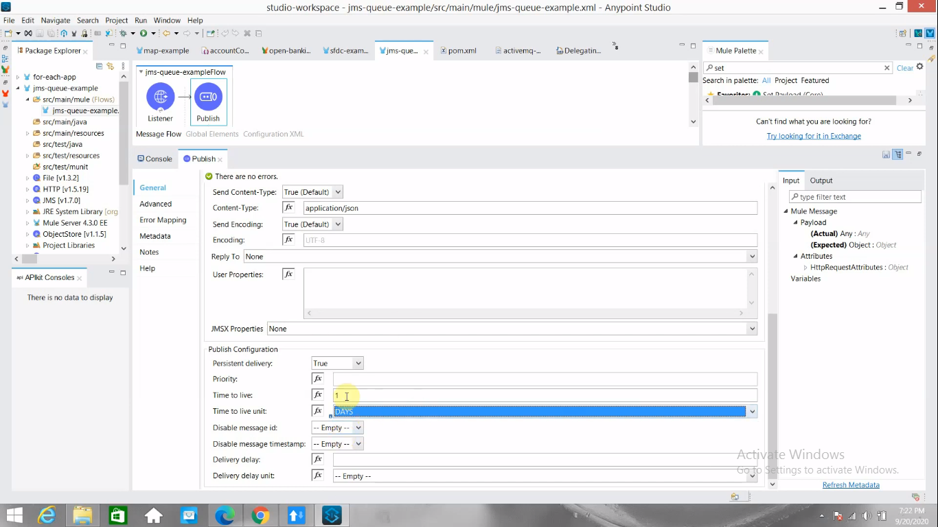

**29. How to use ForEach and FOR EACH PARALLEL Loop in Mule Project?**

1. If we want to perform some operation on Array Of things then We have a forEach Component in Mule pallet and we should drag and drop that to flow and then Add required connector for do some operation.
2. Note: Always we should pass Array to Foreach.
3. For each parallel loop is similar to For each activity but only difference is that it’s iteration will be process by different thread. For each is sequential execution whereas For each parallel as name suggest is parallel execution

**Explanation:**

We have taken 3 as Array Size and try to iterate the Array using ForEach and Parllel with 5 sec sleep time {wait : 5000}

1.ForEach will take 15 sec to complete because it is sequential

2.Parllel ForEach will take around 6 sec because there are 3 threads started for 3 objects in the array and completes by 6th minute.

**30.How to use Batch Process in Mule?**

For example we have huge records to store in DB then we will go for Batch Processor. Have Batch JOB, Batch Set and Aggregator in Mule pallet

We have to add  Batch Job then Batch Set and then Aggregator.

Batch Processing is a way of processing records in batch or in collections. The major advantage of batch job is they execute in parallel and hence provide maximum throughput.

Batch jobs work on incoming payload by breaking them in individual records and processing each record asynchronously. It saves the individual records in persistence store. This will provide the required reliability to Batch processing, as in case of application crash it will resume from the same point where it stopped.

If we drag and drop Batch job activity in Mule 4 then it will automatically create a flow for the batch job. So batch job always expect a payload from the flow’s source section or from the calling flow

**Below are the configuration details we can define for Batch job**

**Name** – Batch job name

**Max Failed Records** –

1-> for every 1 record failure it will send it for next batch processer.

0 -> it will never store failure records to send to next processor.

**Scheduling Strategy** – Batch jobs execution

**ORDERED_SQUENTIAL (the default):** If several job instances are in an executable state at the same time, the instances execute one at a time based on their creation timestamp.

**ROUND_ROBIN:** This setting attempts to execute all available instances of a batch job using a round-robin algorithm to assign the available resources.

**Job instance id** – given or provided to each batch job created for batch processing

**Batch Block Size** – default 100 – Block size define the number of records given to each thread for execution. Bigger the number less I/O operation will be performed by the thread but need more memory to hold block. So always match the block size w.r.t to vCore size (thread count) and input payload. This directly effect the performance of the batch job processing

**Max Concurrency** – Defining the number of threads which can participate in batch processing if you don’t want the default thread count which depends on vCore size of the machine

**Target** – to save the Batch stats result

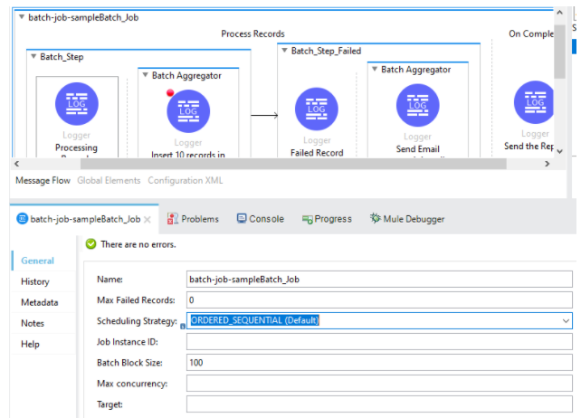

**we can see two sections in Batch Job :**

1. **Process Records:**
2. **Batch Steps:** Each batch steps can contain related processor to work on individual records for any type of processing like enrichment, transformation or routing. This will help in segregating the processing logic.
   1. Accept Expression – expression which hold true for the processing records e.g. #[payload.age > 27]
   2. Accept Policy – can hold only below predefined values
   3. NO_FAILURES (Default) – Batch step processes only those records that succeeded to process in all preceding steps.
   4. ONLY_FAILURES – Batch step processes only those records that failed to process in a preceding batch step.
   5. ALL – Batch step processes all records, regardless of whether they failed to process in a preceding batch step.
3. **Batch Aggregator:** As the name suggest can execute related processor on bulk records to increase the performance.
   1. **Aggregator size** : Processing a fixed amount of records e.g. 100 records
4. **On Complete:**

This is mostly used to provide insight of batch processing e.g. Total record processed, failed, successfully processed etc. In this phase MuleSoft update the payload with batch job stat values.

Note :Batch job is widely used for parallel processing of records but this is not the only activity to achieve parallel execution in MuleSoft. There are other activities like Scatter-Gather, Async and for-Each Parallel is present but they have their own use cases.

**Batch Processing Example 2:**

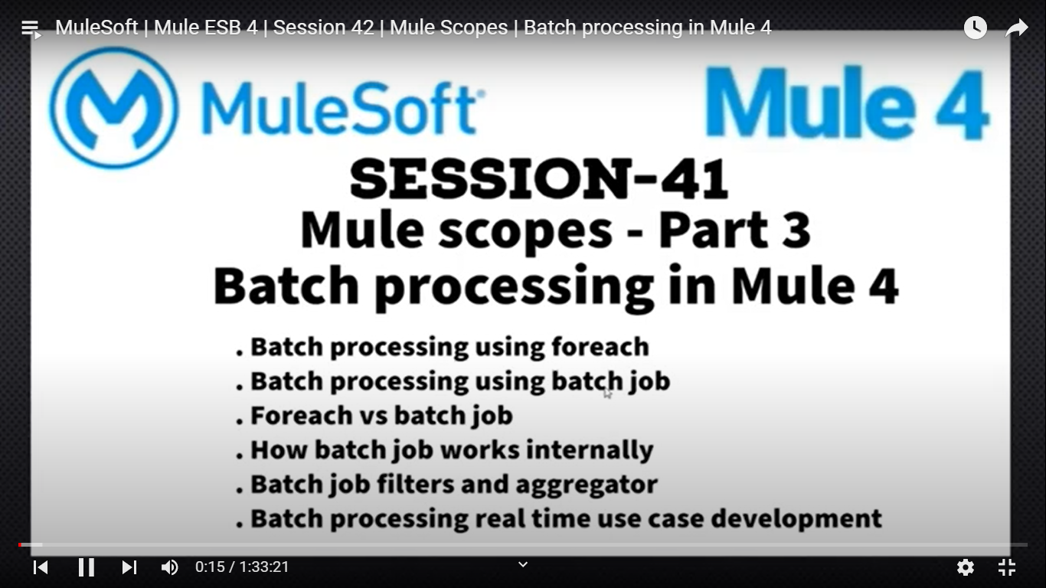

1. 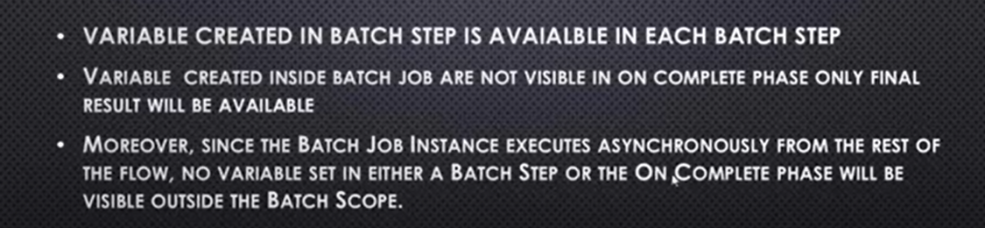

**Different B/w Foreach Batch and Batch Process:**

Inside Foreach Always data will be executed Sequentially but in Batch Process Data will be processed Parallelly.

**Batch Process Steps:**

Batch Process will transfer the huge amount of data between 2 systems parallelly. It will transfer in 3 steps.

**1.Load and Dispatch:**

1. Mule Runtime will take care and created one Batch id[Batch Instance Id] for each batch.
2. Internally it will call the Foreach loop parallelly to process records.
3. Mule Runtime will create threads based on Batch Size like if we have 10 is the batch size then 10 threads dynamically it creates, and the threads will put the data to Persistence Queue and so on for next 10 records.

**2.Process:**

Suppose we have 2 batch process then first all the 10 records will get executed in Batch 1 and keep back to Queue then only it will send to 2nd batch Process.

Suppose we are processing 5000 records in the batch and 4500 got processed and the server got restarted then the Batch will get start from the 4501 and continue the Batch process. Because the Load and process phase the records are stored into the Persistence Queue and it will get processed after server starts.

**Batch Step:** We can use filters and aggregators here.

* Accept Policy: I want send the only Success/Failure/All records to next Batch Process
* Accept Expression: I want to process only the ids are prime odd numbers.

3.Aggrigator:

* + Fixed-Size: batches wise store the data
  + Streaming: At a time all the records

4.On Complete: It is optional and provides the Count of Successful, Failed, Processed records count.

**57. What is Scatter-gather and where to use it?**

1. The Scatter-Gather component executes each route in parallel.
2. Each route receives a reference to the Mule event and executes a sequence of one or more event processors.
3. Scatter-Gather component to have at least two routes; otherwise, your Mule application throws an exception and does not start.
4. Use Try scope in each route of a Scatter Gather component to handle any errors that might be generated by a route’s event processors
5. Suppose we have done in sequential then Query1 takes 2 sec and Query 2 takes 4 sec then total time takes is 6 sec but if we uses Scatter-Gather then it takes 4 sec.
6. We collect S-G results using flatten[payoad..payload]

**Exception Handling in Scatter Gather:**

<https://www.prostdev.com/post/scatter-gather-integration-pattern-mule-4-part-2>

**31.What is look up method in Data Weave?**

Lookup method we have in DW to call the private or sub flow from flow .

We can give the flow name , Payload as input to look up Method.

**32.How to pass Path Params,QueryParams,Named Params in Mule?**

1. **PathParameters :** we can pass through url like [http://lh:8081/test/{name}/](http://lh:8081/test/%7bname%7d/)..

We can pass Path parameters when we have mandatory fields and we can pass QueryParams for filter the data or optional parameters.

1. **QueryParam :** we can pass like [http://lh:8081/test?name=’Ravi](http://lh:8081/test?name='Ravi)’
2. **Named Params:** we can use it for setting the Dynamic values to Query Input

**33.What are the Connectors used for JMS?**

1. We have Listener and Publish in Mule for JMS.
2. The Java Message Service (JMS) API is a messaging standard that allows application components based on the Java Platform Enterprise Edition (Java EE) to create, send, receive, and read messages.
3. It enables distributed communication that is loosely coupled, reliable, and asynchronous.
4. Many providers have implemented JMS interface and created the JMS messaging products e.g. TIBCO EMS, Apache active MQ, IBM MQ etc

**34. Steps to connect JMS Listener/Publisher?**

Select the AMQ Connection then follow the below steps

1. Load the JMS JAR
2. Broker URL
3. User name
4. Password
5. Queue Name:

**35.Suppose 1 call takes 10 ms and 2nd takes 15 ms and 3rd takes 10 ms then what is the time taken my Scatter-Gather to executes the all the calls?**

15 mins.

**36.How to read dynamic properties from Properties files or Yaml file?**

1. Properties we can read using ${} or p(‘’).
2. ${} can use any were but p(‘’) can use only in Data Weave Expression .

**37.What is until Successful and why is it used?**

1. We have Until Successful Component in Mule and if I want to retry a functionality more than once then we can go with this.
2. We will get **MULE:RETRY_EXHAUSTED** Error
3. Max Retries: Specifies the maximum number of retries that are attempted
4. Milliseconds Between Retries: Specifies the minimum interval between two attempts to process, in milliseconds, Default value is 1 Min

**39.What is point-to-Point and ESB integration?**

1. P-2-P :it is direct Integration from Application to Application with out ESB.If Components are Increasing then Integration also need to happen and if there are any changes in Source then Target also need to change accordingly.
2. ESB :I ESB will have 3 properties Orchestration ,Transform and Enrich.Whith this 3 properties we can connect different system easily. If Source system is changed then we no need to change in Destination and ESB will take care of it.

**40.How to make Private or Sub flow as Async?**

We can drag Async Component from the Mule Pallet and then Drag the flow reference that is calling the Sub flow on top of it.

**41.How to add logs in Mule?what are the logger types and how to set logger type in Properties?**

1. We can drag logger component and keep the message and we can select the Logger type INFO,DEBUG,ERROR,WARNING .
2. Logger will help us to understand how the flow is executing runtime.
3. While deploying we can mention the Logger type in Properties files in Cloud.

**42.How to configure Schedulers?**

1. Scheduler component will executes specific logic automatically with given Time period or Cron Job Expression.
2. We can give the **start delay** .First time after server restart **start delay** will consider.
3. We have schedulers for Activate/Deactivate/Assgin/Unassgn Vehicles.
4. Archival jobs to move the History data to S3 bucket.

**43.How to use JOINs in DWL?**

**JOIN,Left JOIN,OUTER JOIN :**

Joins are for join the 2 different objects based on some related Id.

**Join:** Notice that the output only includes objects where the values of the input user.id and product.ownerId match. The function includes the "l" and "r" keys in the output

**Expession :** join(users, products, (user) -> user.id, (product) -> product.ownerId)

**Left Join:** Notice that it returns all objects from the left-side array (left) but only joins items from the right-side array (right) if the values of the left-side user.id and right-side product.ownerId match

**Expression:** leftJoin(users, products, (user) -> user.id, (product) -> product.ownerId)

**Outer Join:** outerJoin returns an array with all the left items, merged by ID with the right items in cases where any exist, and it returns right items that are not present in the left.

**Expression:** outerJoin(users, products, (user) -> user.id, (product) -> product.ownerId)

**44.How to use DROP,TAKE,PARTITION?**

Input: var array = [1,2,3,4,5,6,7,8]

Drop: drop(array,2)

Output:[ 3,4,5,6,7,8]

Take: take(ayyay,2)

Output:[1,2]

Partition: Employee partition ((item)-> item.sal >10000 and item.age>18)

Here 2 arrays will get created one is successful and other is failure based on condition.

**45. How to implement BASE64 Encoding ?**

1. **HMacBinary (Binary,Binary)**

Import dw::Cripto

{

“HmacBinary”: Cripto::HMacBinary(“Ravi Hwllo”as Binary,”Mule Dveloper” as Binary)

}

2. **HMAcWith (Binary,Binary,Algorithm)** Note: Algorithm we can pass as HmacSha256 and HMacSha512.

3. **MD5**

“MD5”: Cripto::MD5(“Hellow ravi “ as Binary)

4. **SHA1**

“SHA1”: Cripto::SHA1(“Hellow ravi “ as Binary)

5. **hasWith()**

“hasWith”: Cripto::hasWith(“Hellow ravi “ as Binary,”MD2”)

“hasWith”: Cripto::hasWith(“Hellow ravi “ as Binary,”SHA1”)

“hasWith”: Cripto::hasWith(“Hellow ravi “ as Binary,”SHA-256”)

“hasWith”: Cripto::hasWith(“Hellow ravi “ as Binary,”SHA-384”)

“hasWith”: Cripto::hasWith(“Hellow ravi “ as Binary,”SHA-512”)

**46.How to call Java Methods in MULE DWL?**

If we are not able to achieve some thing using DWL then we can write java methods and use in DML.

Create java class with static method in /src/main/java FOLDER.

**In java class I have written like below:**

*Class ApplicationDemo{*

*P s void applyHello(String ss){*

*Return ss+”Welcome JAVA”; }}*

In declaration section we can import the java class : inport java!com::example::ApplicationDemo

In payload section {name: ApplicationDemo :: applyHello(“Hi ravi”)}

**47 .How to call Instance methods in Mule DWL?**

We have to created 3 different dw files for different customers and keep the response formate in that files.

Add the lookup properties in the loopup Properties file like key,value pair

Drag new component and then configure class name and constructor and Target value need to set.

Then drag invoke component and do the configuration as instance = vars.vInst

Args :{

Firstname

LastName

}

Class and method.

**48.What is choice when to use it?**

1. Choice is used for to execute some functionality based on condition like if else lader in java .
2. Suppose first condition is satisfied then it wint check other conditions.
3. If no condition is satisfied then it will go to Default

**49.How to implement CIRCUTE Breaker in JMS?**

<https://mulesy.com/circuit-breaker-for-anypoint-mq/>

1. Suppose we are receiving some data to our flow and there is a problem in our flow and messages are failing to persist in db.To avoid the data loss we will apply the Circuit Breaker
2. The basic idea behind the circuit breaker is very simple. You wrap a protected function call in a circuit breaker object, which monitors for failures. Once the failures reach a certain threshold, the circuit breaker trips, and all further calls to the circuit breaker return with an error, without the protected call being made at all
3. The circuit breaker capability is bound to the error handling mechanism provided by Mule.. You can bind any error to a circuit failure. For example, you can bind HTTP:TIMEOUT, MULE:RETRY_EXHAUSTED, or even a custom error from your app, such as APP:CUSTOM_ERROR
4. If a Mule flow finishes its execution with an error, the Subscriber checks if the error is for the defined ErrorTypes then it counts consecutive occurrences for that error until **errorsThreshold** is reached. When errorsThreshold is reached, the circuit trips and stops polling for new messages the duration specified by tripTimeout
5. Create a new mule application and drag and drop Anypoint MQ subscriber operation
6. Create configuration for Anypoint MQ, provide the URL, and client id and client_secret to connect with Anypoint MQ( you have to create a new client_apps below destination tab on MQ Home page)
7. Go to Global Elements-> Create->Component configuration->click on Circuit breaker

**We should Provide the below properties for Circuit Breaker ::**

1. **On Error Type:** Error type which will decide the circuit breaker to trip, it can be any error you can provide multiple error type as comma-separated values.
2. **Error Threshold:** This is the threshold(no of consecutive error) after which the circuit will open
3. **Trip timeout:** This time decide for how long the circuit will keep open
4. **Trip timeout Unit:** Unit for trip timeout like below
5. 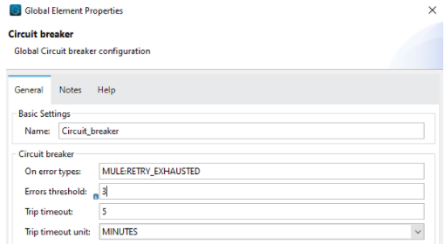
6. 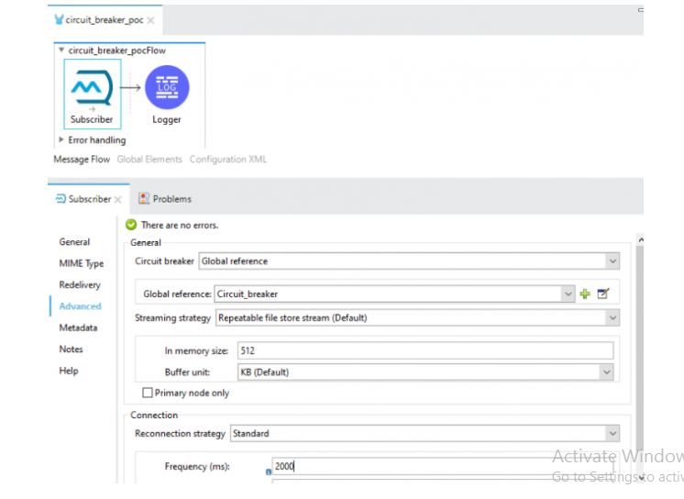
7. Below is for configuring CIRCUIT Breaker



15 . Configure the HTTP Requester to make a rest API call and wrap the HTTP Requester under until successful to retry the HTTP Request in case the service is not available after all the Retry is exhausted Retry exhausted, after 3 consecutive MULE:RETRY:EXHAUSTED circuit breaker will trip off.

16. You will see after 3 consecutive error circuit is trip off(open) for 5 minutes and after 5 Minutes the circuit will half closed/open to check if the API is available or not, if the API is available it will be close again to consume all the message else it will be kept open and wait for the complete recovery

**50.How the cache works in MULE?**

1. We can do the Cache mechanism in Mule and we have to create separate component to handle cache and access through Caching Policy [API Gateway]
2. In Memory Object Store: Store the data in Volatile or ram
3. Persistence Store : Store the data in Hard Disk
4. If we want to Store in Sync through cluster : Object Store V2 or External cache

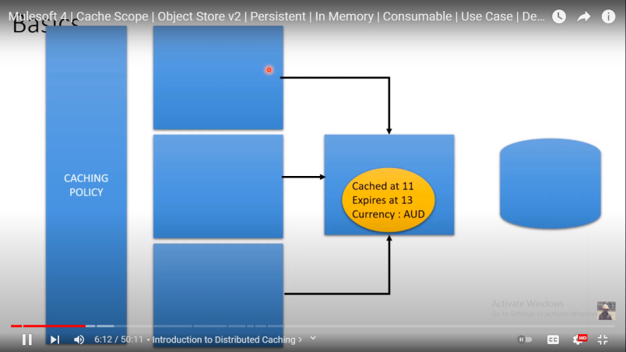

**Default Cache:**

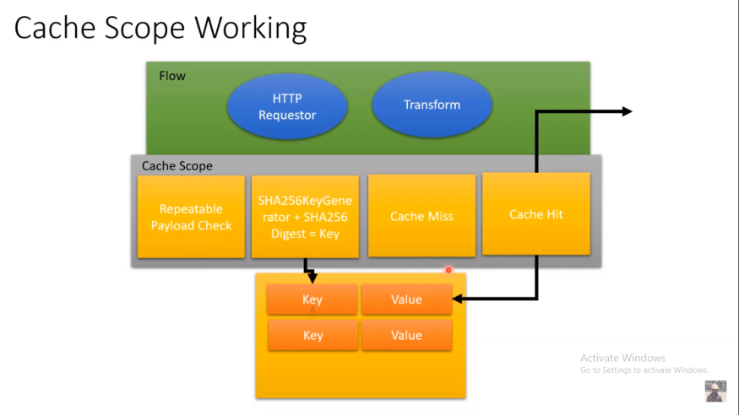

Always Mule will Uses Default cache .It will use the payload properties to Create the Key for storing the Value for avoiding unwanted hits to the flow.

If the Payload presents in the cache then returns the value or it will hit the flow and get the data.

**Different cache mechanisms:**

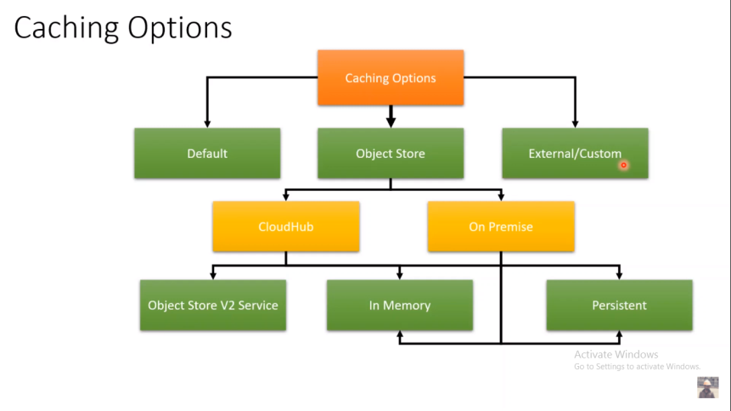

**When we go for Cache:**

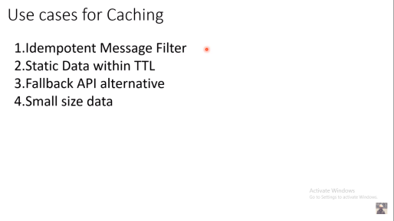

**Idempotent Message filter :** It is used for avoid duplicate calls like if I have already paid the payment but did not get the response and again if I click then 2nd time I don’t want to deduct the amount again and it should say already payment is done like that

**Static data with in TTL**:If I have static data in DB and every 2 hrs the data will get change then TTL time we can configure every 2 hrs.

**Fall Back API Alternative:** Suppose Circuit Breaker is opened and We are getting error response always then we will call alternative API and if the Alternative API also down then we can read the Cached data.

**Small sized data:** If we have small data then only we have to do the Cache otherwise we have to check alternatives not the Cache

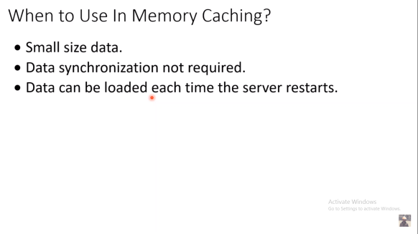

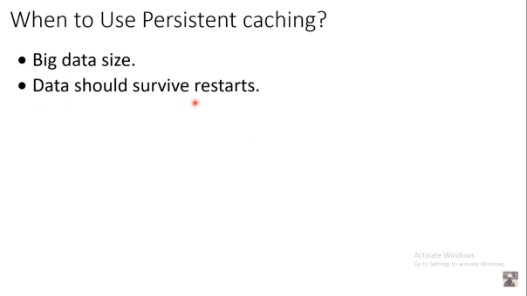

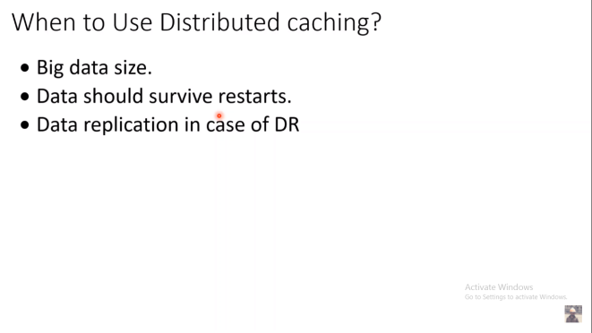

DR means Disaster Recovery.

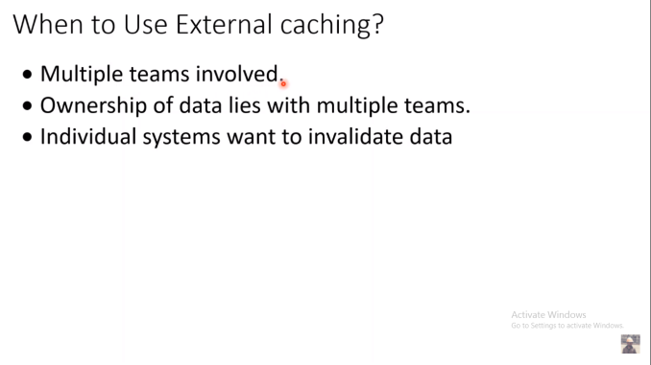

**Demo :Default Cache**

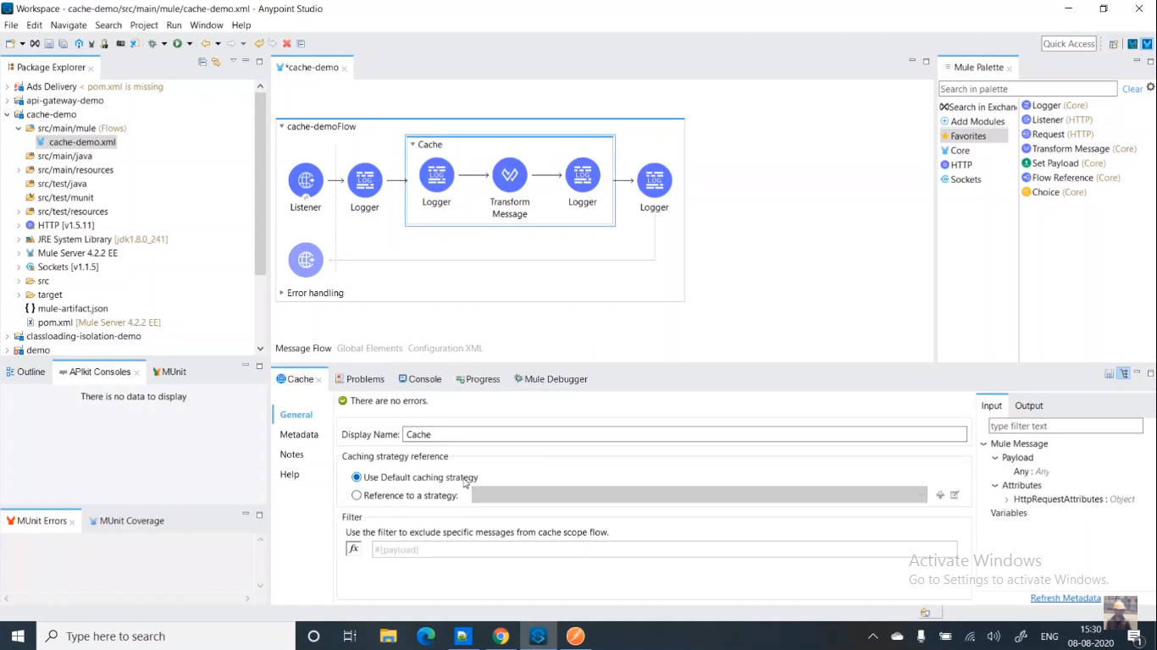

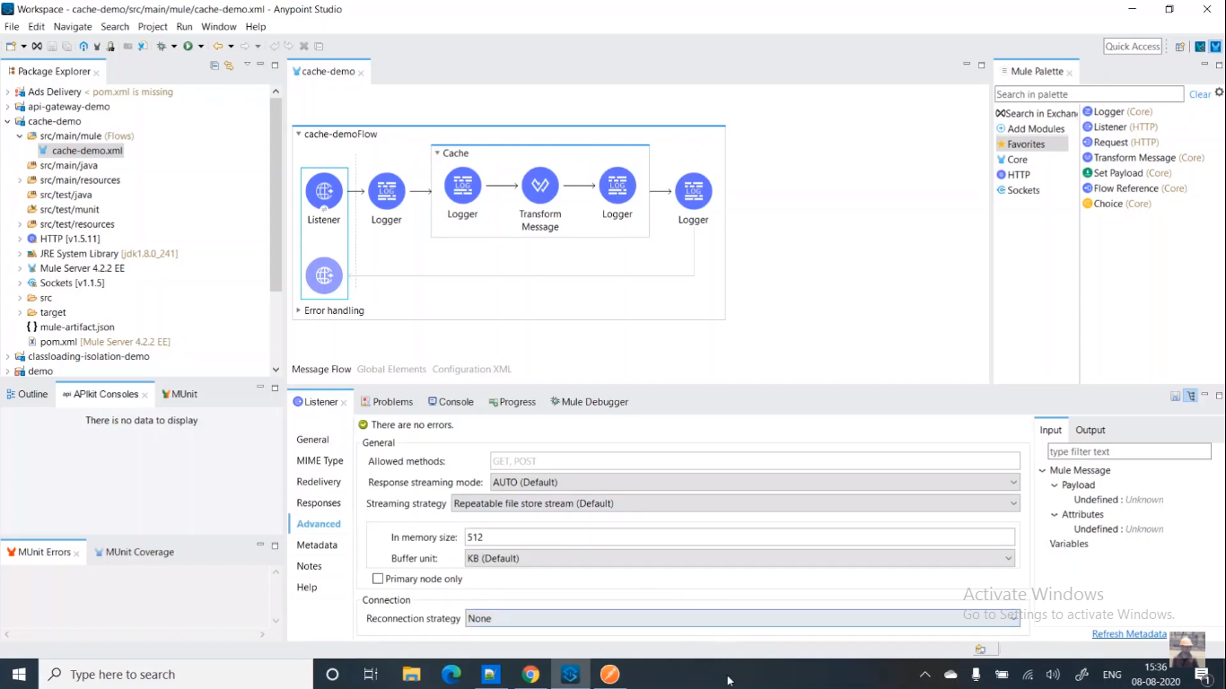

We have filter condition to Cache Specific Data like below

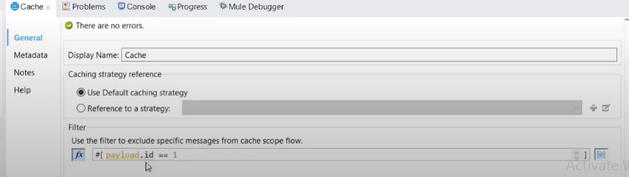

Instead of Default we can define the cache key mechanism like below:

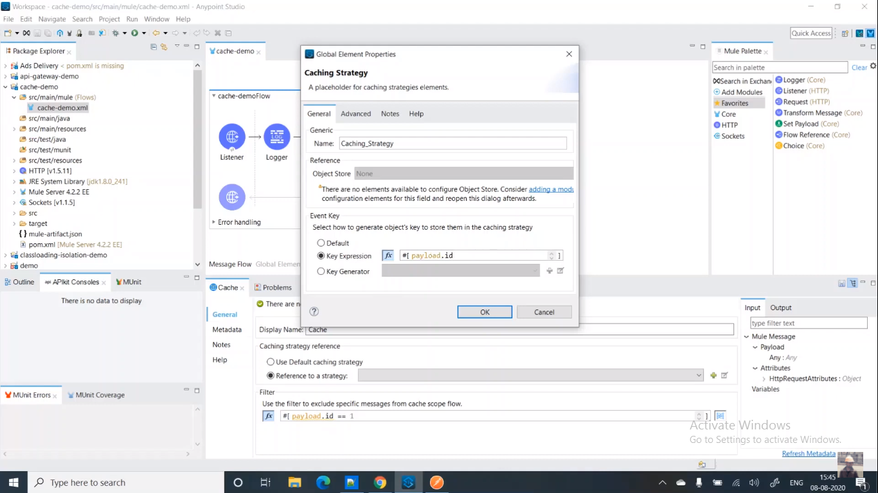

**Using Object Store:**

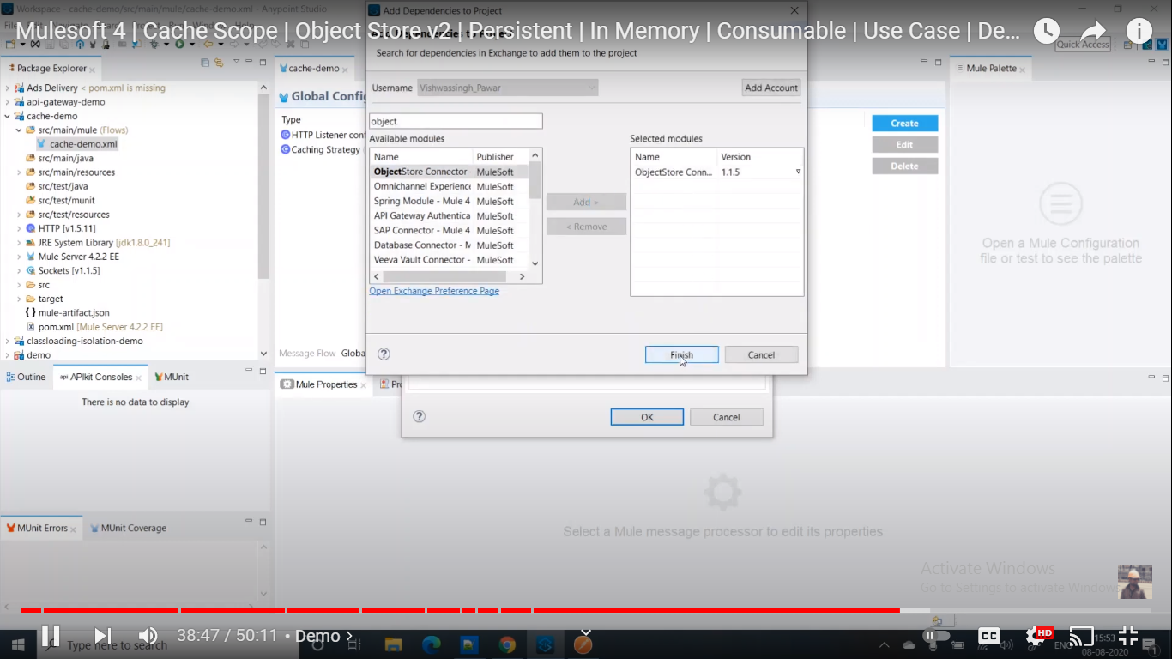

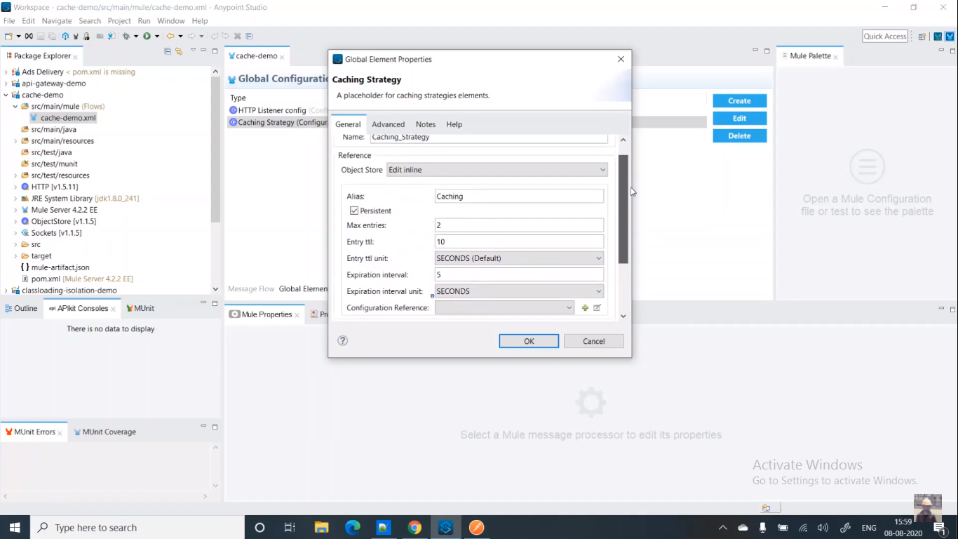

Cache files location:

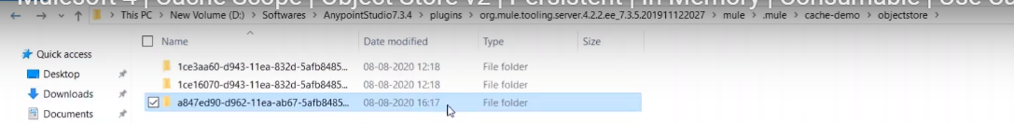

**Object Store Options:**

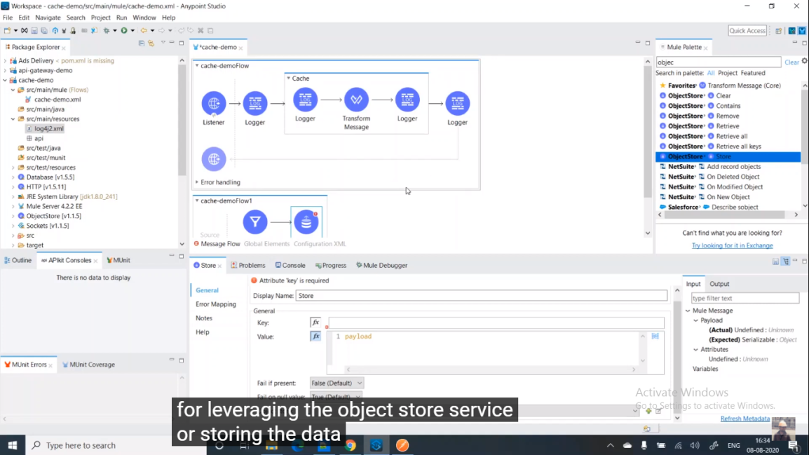

**70.What is the Error hierarchy in Mule?**

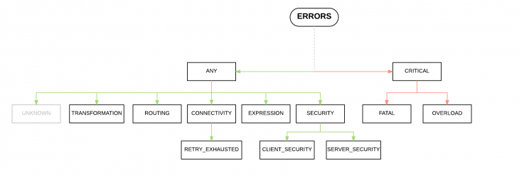

**71.How to handles Errors in Mule? What are error handling ways ?**

1. We can handle error 2 ways .
   1. .Project Level Default Error handling
   2. .Project Level Global error Handling
2. We can do Flow level error handling using Below
   1. .On Error Continue
   2. .on Error Propagate
3. raise Error
4. We have try and we can use it at flow level or Processor level
5. When there is a error occurred in the flow an error Object is created.It contains 2 properties
   1. .error.errorDescription
   2. .error.ErrorType
6. ErrorType is combination of Namespace & Identifier.Ex.**HTTP:UNAUTHORIZED**
7. Mule will identify error based on Error Type,
8. Sub Flows don’t have error handling scope but we can use try in Sub flow from Mule 4.

**72.How to classify error in Mule?**

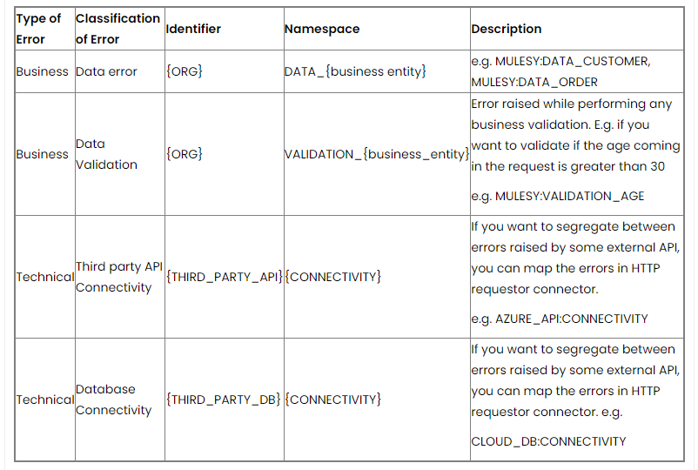

**72.How to create User defined Errors or throw errors?**

We can drag raise Error component and we will configure User defined Error there with ErrorType

**Ex.**RAVI:PROJ_EXCEPTION[NAME SPACE AND Identifier] 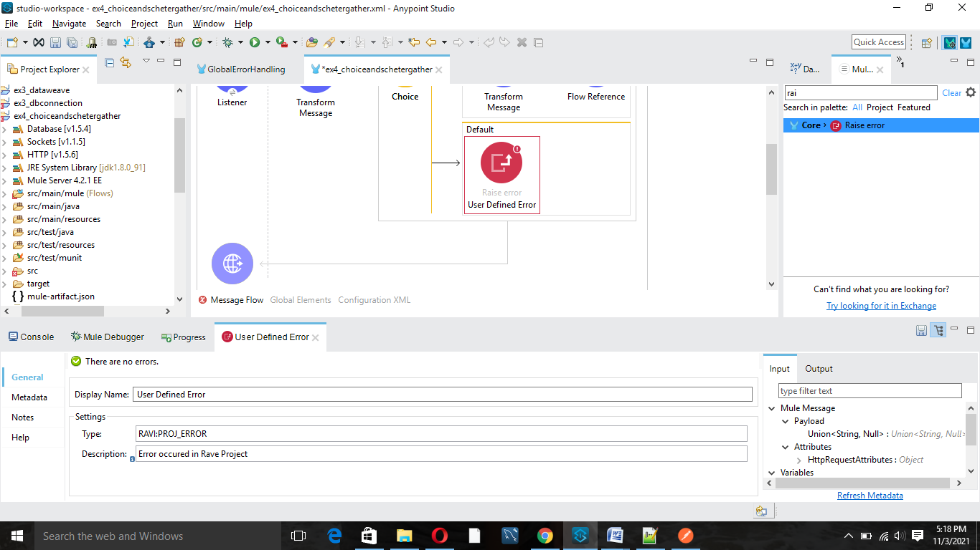

The raised error we need to Handle in Flow or Global Exception handler or it will raise a default error.

**73.How to configure Global Exception Handling?**

We can create separate xml file for Global Exception Handling like below.

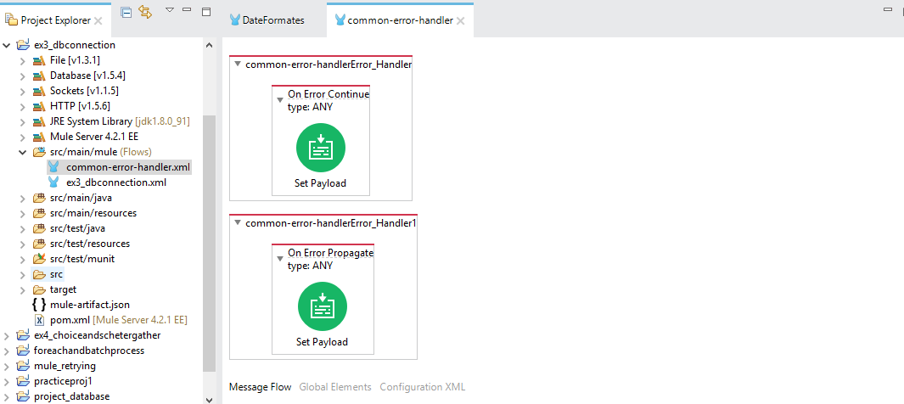

Config the Global Exception Handler for the Project.

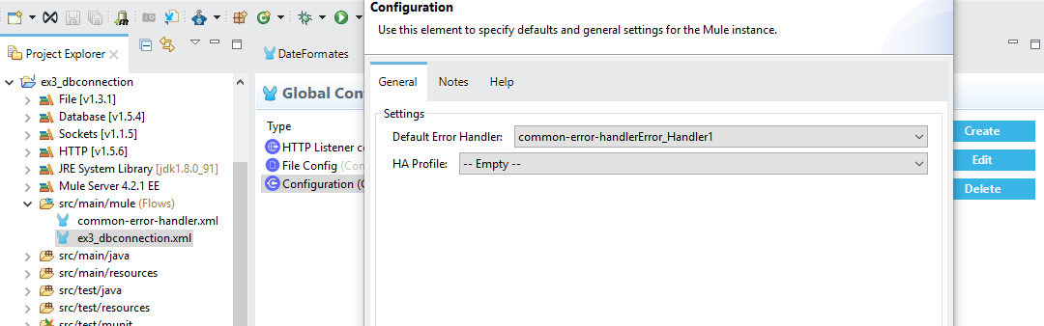

After this we can see below the actual project flow.

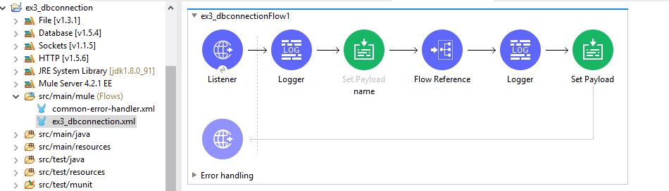

When we run the above flow and if there is any exception then it will go to Global exception handler if we are not handling in flow level and returns the error

**75.How on error Propagate and on error Continue behaves in main flow?**

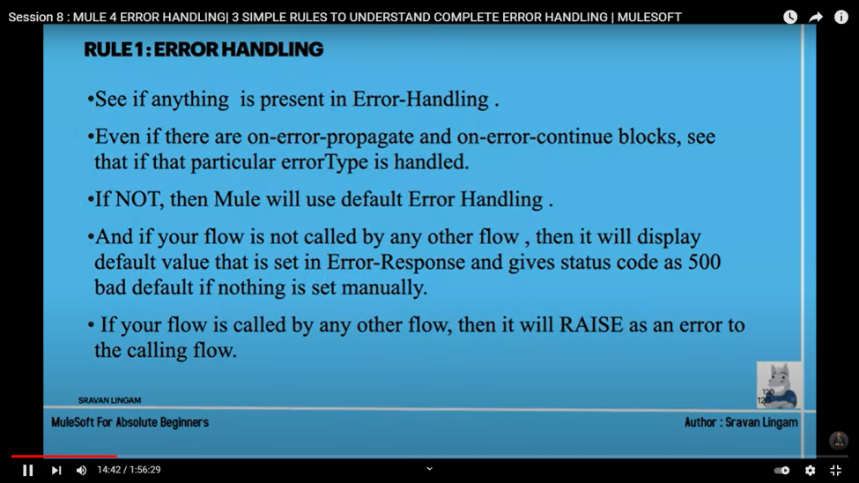

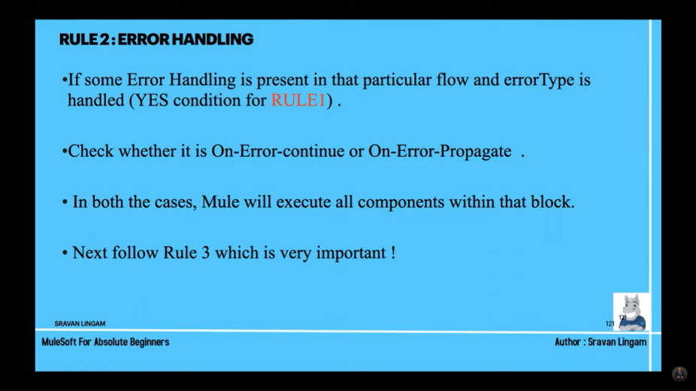

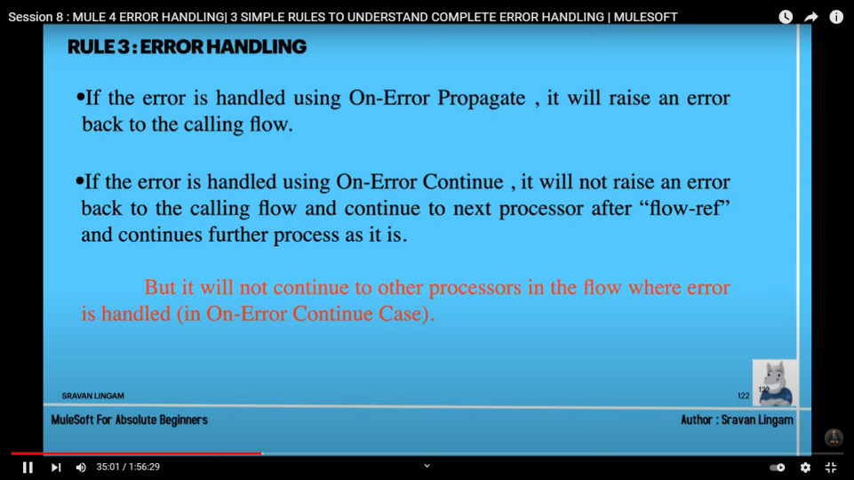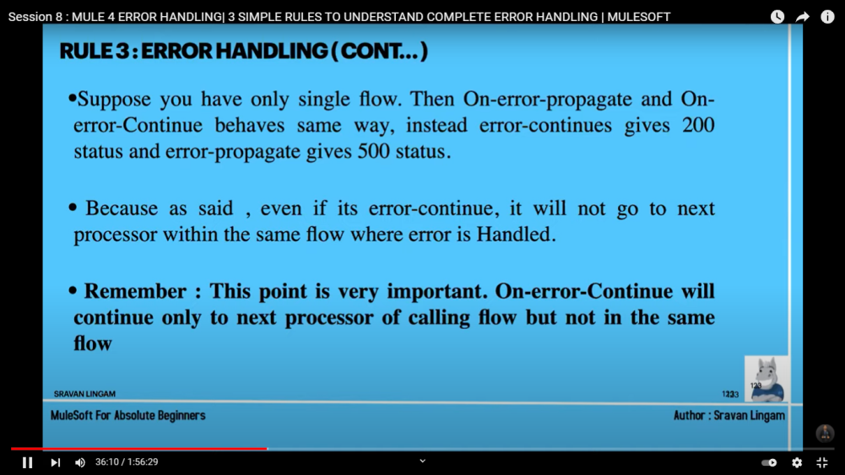

**77.How** on error Propagate **and** on error Continue **behaves in sub or Private flow?**

Refer the above Slides

**78.Can we handle Error in Sub flow?**

From Mule 4 we can do using try.Other types won’t support

**79.How to enable logs in Mule?**

1. If we give DEBUG then INFO,ERROR and DEBUG
2. If we give INFO ten INFO and ERROR
3. If we give ERROR then ERROR
4. **HTTP Connector :** <AsyncLogger name=”org.mule.service.http.impl.service.HttpMessageLogger” level=”DEBUG” />
5. **For FTP :** <AsyncLogger name=”org.mule.extension.ftp” level=”DEBUG” />
6. **For BD :** <AsyncLogger name=” org.mule.extension.db” level=”DEBUG” />
7. **For JMS:** <AsyncLogger name=”org.mule.extensions.jms” level=”DEBUG”/>
8. **For VM :** <AsyncLogger name=”org.mule.extensions.vm” level=”DEBUG”/>

**49. What are the Connectors used for File,Ftp,Sftp?**

**File :** Copy,Read,Update,write,Rename,on new or update file,move,list

1. File connector is used to handle files folders on a local file systems and FTP ,SFTP will used for accessing and do operation on remote files
2. **File-connector features:**
3. Ability to read files
4. Writing files to directory
5. Copy and move files
6. Locking file so that no one can access file when the processing is going on
7. Listing the files and folders mentioned at directory path
8. Trigger a flow when the new file created or modified

**Operation available:**

1. Copy
2. Create Directory
3. Delete
4. List
5. Move
6. On New or Updated file
7. Read
8. Rename
9. Write
10. File Locking while read and write
11. 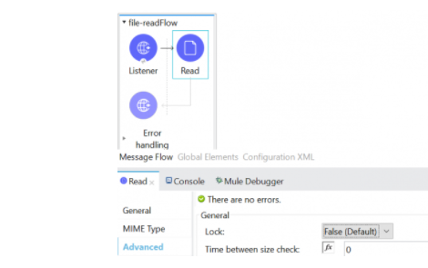

If the file is already lock and some other process trying to lock it the operation will throws File Lock Error

To set the lock flag as true you can set this on advanced tab on connector configuration

**TRIGGER FLOW ON NEW OR UPDATED FILE:**

File connector provides a listener that polls a directory for files that have been created/updated. A message is generated for each file that is found. Let’s see how we trigger flow on new/updated file.

Create project in Any point studio

Drag and drop on New or Updated File from mule palette

Configure the below parameters:

* **Directory:** provide the directory path
* **Matcher:** Use a matcher to filter the files
* **Watermark:** Use the watermark parameter to only pick files that have been created or updated after the last poll was executed by default it is disabled
* **Schedule Frequency:** configure the frequency to poll the directory

**Once the file is processed you can configure below parameters**

* **Auto Delete:** file delete after processing default is false
* **Move to directory:** configure the directory for processed file
* **Rename:** rename file after processing
* 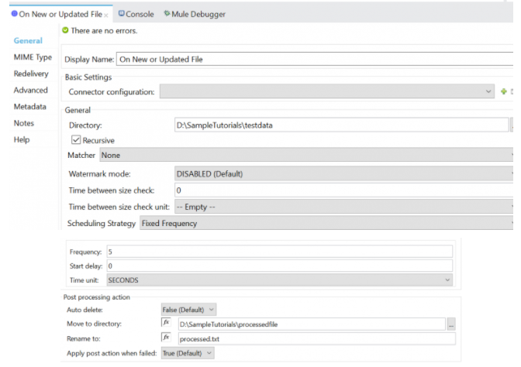

**Watermark:** It is used to avoid the duplicate records from a table or duplicate emails from inbox or Files from a directory from the last poll.

**Poll Configuration for Record from DB:**

* Drag and drop On Table Row from mule palette and configure the below parameters
* **Table:** Table name to process the records
* **Watermark Column:** The name of the column to use for a watermark. Values taken from this column are used to filter the contents of the next poll, so that only rows with a greater watermark value are processed.
* **Id:** The name of the column to consider as the row ID If provided, this component makes sure that the same row is not processed twice by concurrent polls.
* **Scheduling Frequency:** Configures the scheduler that triggers the polling it can be either cron or the fixed frequency

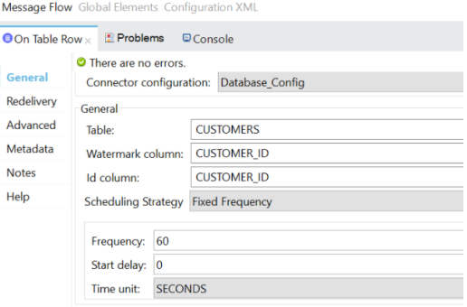

**50. Steps to connect FTP or File or SFTP?**

1. FTP and SFTP both we will use for Connect Remote Files.
2. Create a SFTP configuration and provide the username, private key and passphrase as below.
3. We need username and password to connect using SFTP or Username and passphrase is fine without password.
4. If there is any proxy then we need to set proxy server details also to SFTP
5. For FTP we need HOST,PORT,USERNAME,PASSWORD and If required then need to open the port

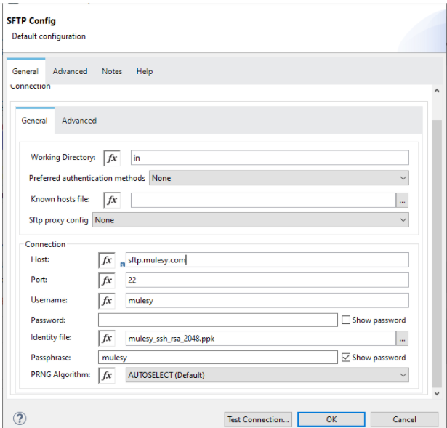

FTP Configuration:

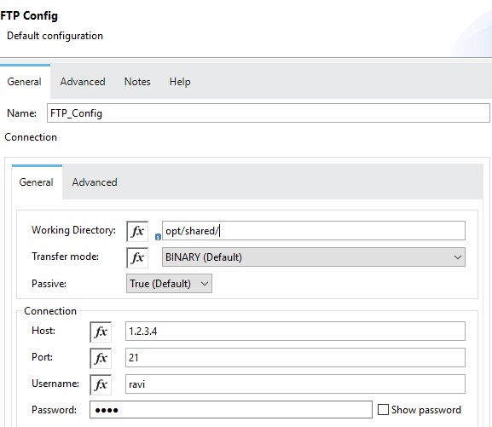

**51. Have u used s3 for storing any files?**

Yes .We have used for storing the History data to Archive.

**52. Steps to connect S3?**

1. Drag and drop create object S3 connector and configure the bucket name and key name
2. Complete the amazon S3 connector configuration with connection details

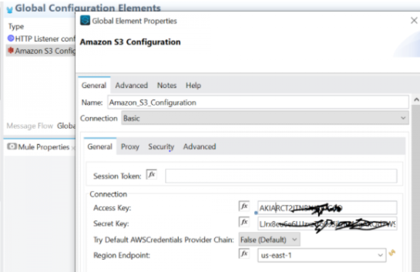

**53. Have u connected Sales force or Sap or Oracle DBA using Mule?**

I have not done as of now but I saw some connectors to connect to Salesforece and create accounts ,delete,update like that .For OracleDBA and SAP as I k now not available from AnypointStudio default and we have to add from outside and use.

**58. How the Scatter-Gather Response Looks like in Mule 3 and Mule 4?**

Mule 3 it is Array Of objects [{},{},…etc]but in Mule 4 it is like “0”:{},”1”:{} …etc

**56. How to Design REST API in Any Point Studio?**

1. We should use Any point Platform to Design APIs.After creating the API we can mock the actual service[Actual service simulator] then we can provide this to client for review.This mock service will work as actual service with static input and put put.
2. API:Appilcation Programer interface.If is an interface between the source and destination to start the development Parlelly.

**59. what is traits, securitySchema, dataTypes and examples? Explain?**

1. **Security Schema:**For Oauth or JWT or any other security we can create Security Schema for Reusability.
2. **Traits:** for Transaction Id As Header we creates Traits for Reusability
3. **DataTypes:** We can use the Data types for JSON payload **vaidation**
4. **Examples:** we can keep request and response payloads here and dynamically provide to the APIs

How to access All this Fragments to raml file.

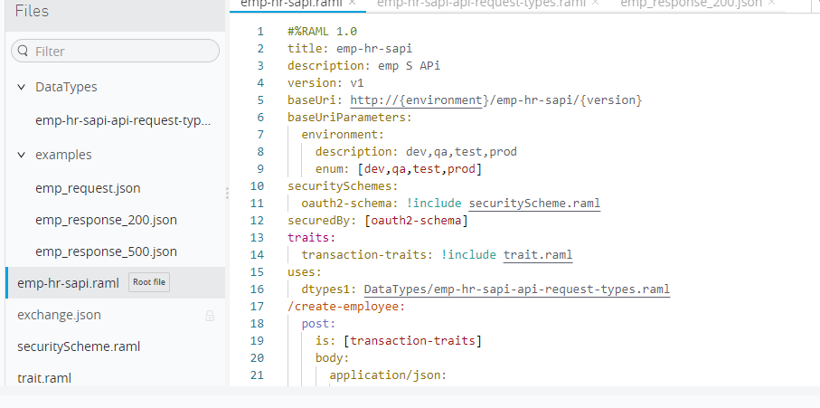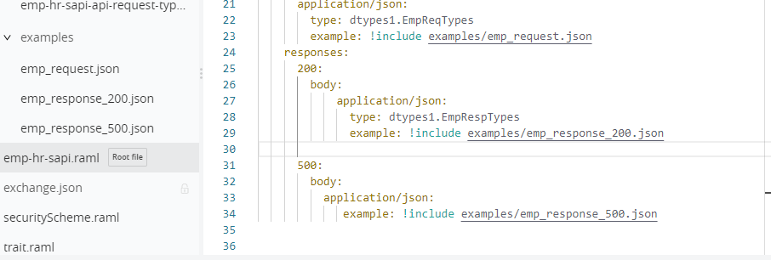

DataTypes:

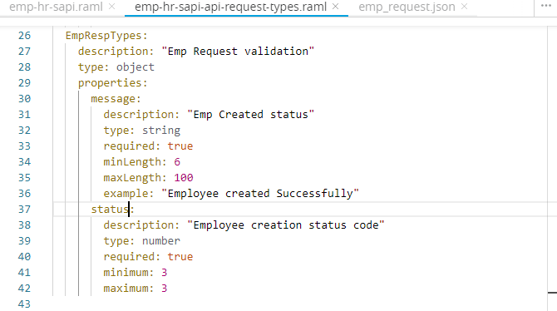

Examples:

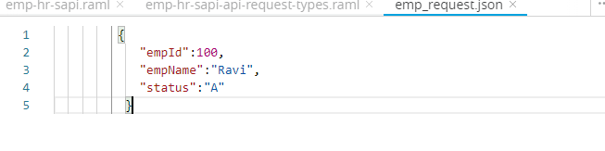

Security-Schema:

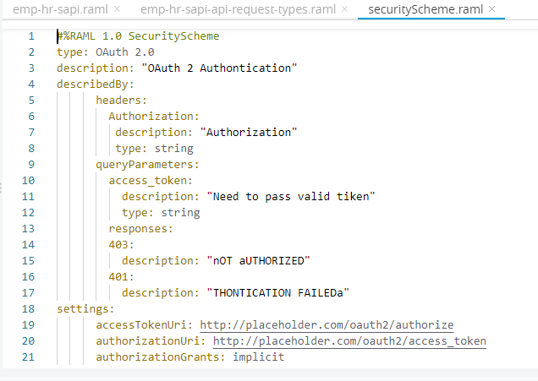

Traits:

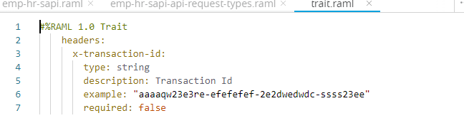

**60. Can we design SOAP Service? if no then why? If yes then how?**

We don’t have option for design soap services in AnyPoint Platform.We should design WSDL Outside AnyPoint Platform and development we can import to AnyPoint Studio and do the development.

We can deploy the SOAP project in Anypoint Platform and manage it.

**65.Ho to Apply OAuth2 ,JWT ,Client secrets?**

**OAuth2:**

We should be having 2 url for OAuth2 1.server and 2.client.

Server url we will configure for our api in Any point platform under policies ->OAuth2 -> in Policies->

Access Token Validation endpoint url -> add the Oauth2 server url there.

We will get the token from the client application. Using the details from above screen shot.

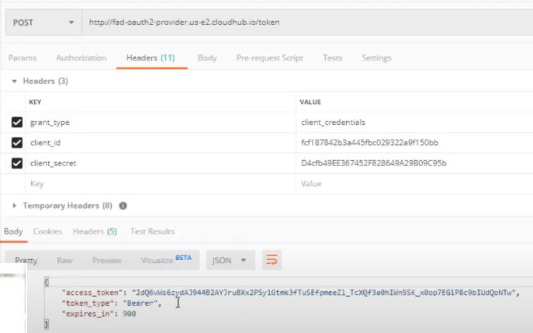

We should pass the Token from our actual api as headers like below.

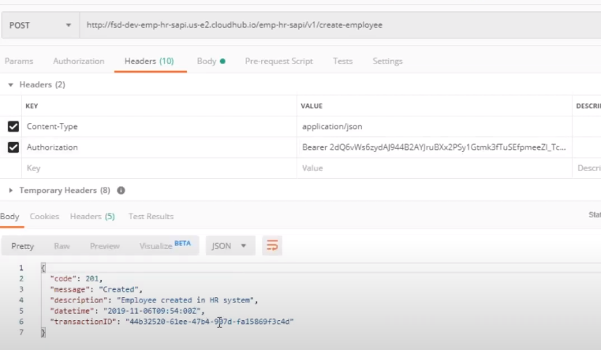

If we don’t pass the Authentication token then we will get the 401 Unauthorized

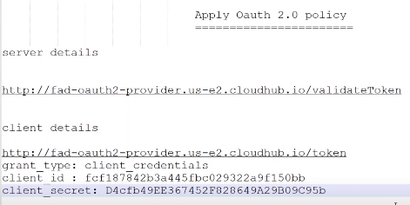

**JWT:**

**Client secrets:**

**66.How to generate Proxy in AnyPoint Platform for our API?**

After Deploying our APi in runtime manager after that created the api in API Manager then we can go for Proxy generation.

In API manager we can click on our API and Manage Type with 2 options 1.Basic End Point and 2 .EndPoint with Policy

Select 2nd option and click on save.

It will ask for the End Point URl and RAML version:

1. We should select RAML version

2. Suppose our actual URL is <http://fsd-dev-emp-hr-sapi.us-e2.cloudhub.io/emp-hr-sapi> and our application name is fsd-dev-emp-hr-sapi and we should configure similar name to Proxy application name.like -dev-emplopee-hr-sapi and click on deploy.

3.After that new application will get deploy with name we have given. A New end point will get generated and we should share this with customer.

4.This Proxy is wrapped to the Actual service and it will pass the input to the actual service and call it.

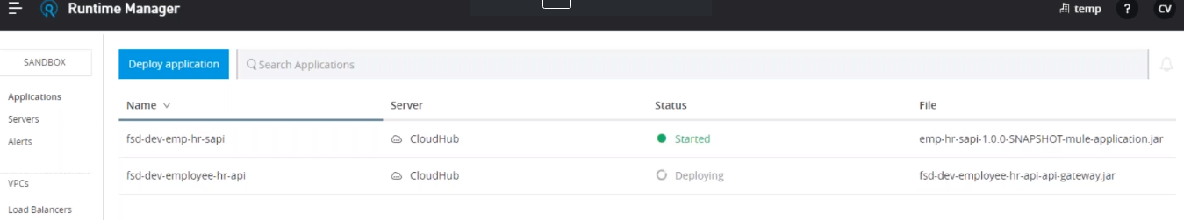

**69.How many ways we can deploy Project to Cloud?**

We can deploy Mule Application using 2 ways 1.Cloud Using APF Runtime manager and 2.On-Prim

1. In AnyPointPlatform->Runtime Environment->Deploying Application->give Application name[Unique for all the applications deployed from the world]->Deployment target[Cloud Hub] ->

Application file will get generate ApplicationName.jar ->

2. Minimum **0.1 VCore** we need to deploy any Mule Application.

**3. Properties:**

Already we have the Properties based on Env like **dev,Qa,PROD** but if we have any common properties to all the environment then we can place under Properties in Runtime environment from Any Point Platform.

**Ex:** mule.env = dev then it will load the dev.properties file

**Vcores:** It defines how much memory need for the Project

**Workers:**It will be like how many servers we need to deploy to serve the user requests.Load balancer will take care of redirecting the request to the Workers

**Logging:** we can configure the log level here and if u put info here then we can see only info and error but not able to see the DEBUG.

**61. What is API Manager? How to Apply Policies in API Manager?**

1. Publish API to Exchange

2. Import to API Manager

3. Configure APF and business group client id and secret properties

4. Apply Policies.

Exchange: it is used to provide the Project documentation to Customers for consuming the service. We can edit the services in Exchange and then Add the extra details if required.

Exchange will maintain more connectors like user defined connectors. It contains private and public domains. Whatever we have developed APIS we can publish as public or private.

After we import the Application from Exchange to Runtime manager we will get the **Auto Discovery Id** and we will get the Implementation URL..

We should copy that Id and Create API Autodiscover Config file and give the AutoDIscoveryId As key and Application name as Value in Project Configuration and then deploy the Application again.

**Access Management:**

We need to create Our Business Group to deploy our application. Always we should deploy applications into Our Business Groups.

After creating the Business Group then we will get Client ID and client Secrets from the business group then take it and go to **Studio => Preferences => Any Point Studio =>API Manager => fill the Any Point platform URL and Anilities URL and Client Id, client secrets URLs.**

Actually creating Business Group and adding this Client Id and Client Secrets is CICD Dev Ops Job as a developer we no need to do.

After this we have redeploy the Application and we can see the properties in APF Runtime Manager in common properties like below in

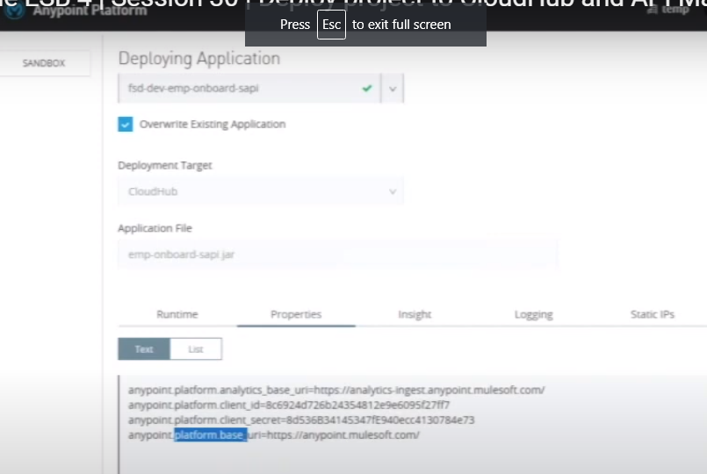

**66. How to Setup and work Auto Discovery?**

1. Auto Discovery is used to identify the Application already deployed in Runtime manager to API manager to apply the policies. Why because if we have 100 applications deployed in in Runtime Manager and if we apply policies in API Manager then We don’t know which Policy will be applicable for which Project or api.Using Auto Discovery ID we can apply Policies to specific Applications.
2. We can avoid creating Proxy Application if we will use auto Discovery.

**63.Have u done Any Policies for ur API’s ? What is that? .What is rate Limit and how to configure?**

**How to Expose API from Any Point Platform Design centre to Exchange and then API Manager?**

If we import the Project Design from Design centre to Excahnge then Assert version will be increased like 1.0.0 to 1.0.1

But APi version will be not changed.

We can publish the API to Public Portal and others can use it for their Projects.

1. We should deploy the Application from Studio to Cloud or using CI/CD Process.
2. Take the Domain name and replace the **localhost:port** to Domain name.
3. Create API Proxy
4. Basic Proxy and EndPoint with Proxy we can see the options under Proxy
5. Select EndPoint with Proxy

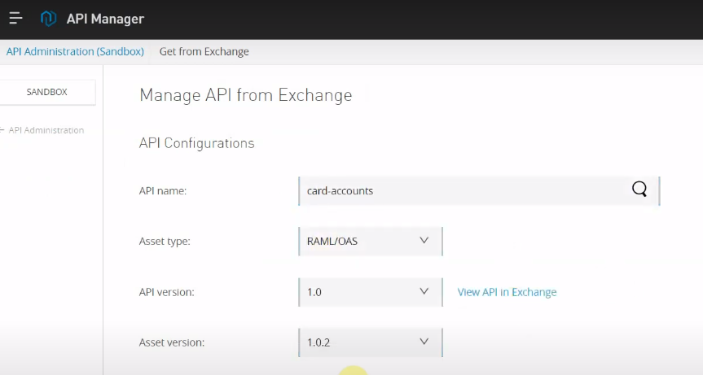

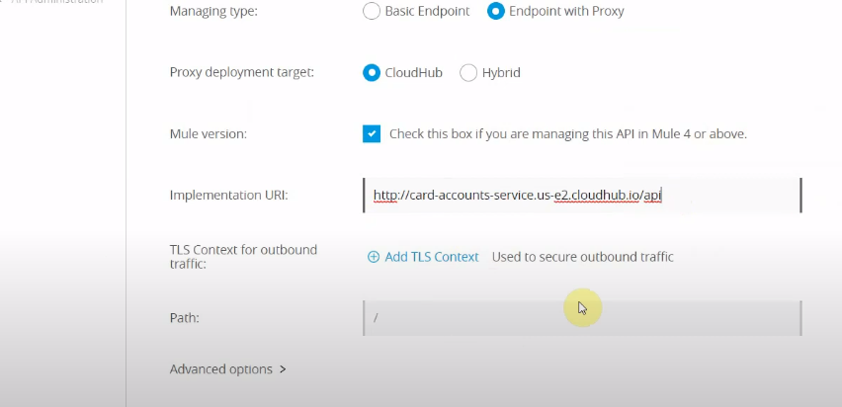

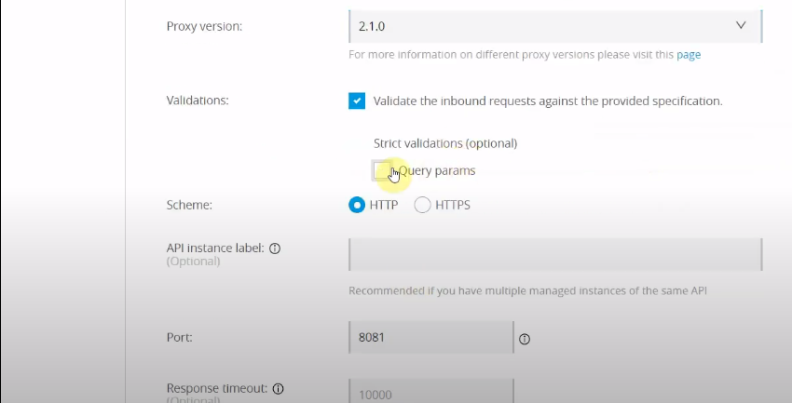

Then save the Configurations.

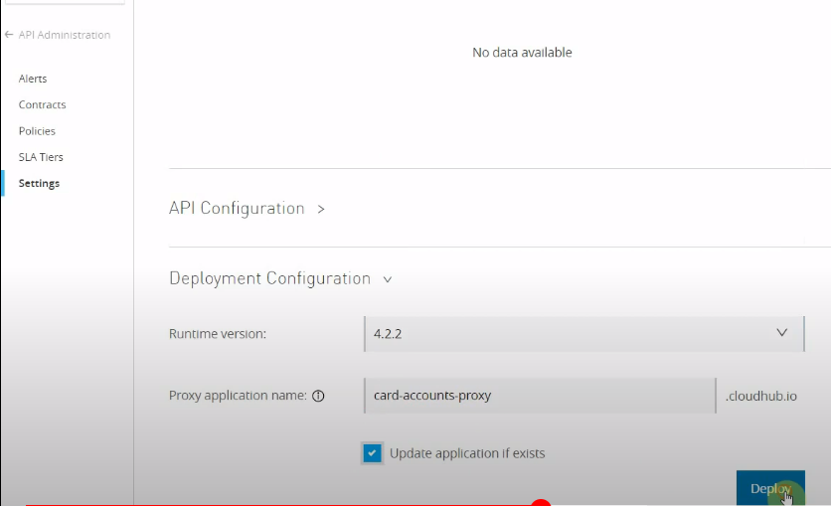

Finally Click on Deploy.

If we go to Runtime Manager we can see 2 applications like actual and API Gate way for the Proxy.

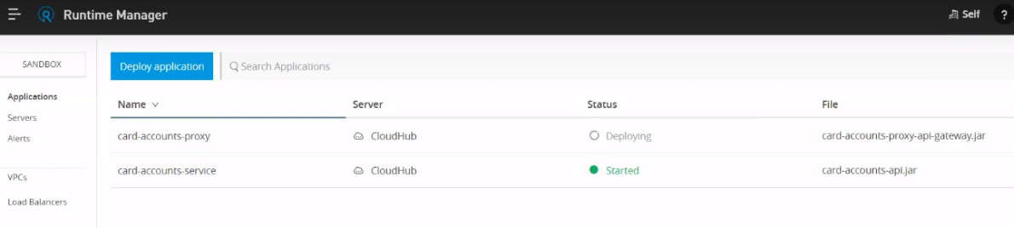

But if we go for Proxy then extra Vcore and workers need to Purchase.

Advantage is the customers never Access the Actual API and they always hit Proxy and it is more secured.

It will be like AWS Gateway.

Below screen shows the Actual and the Proxy URL that users can access.

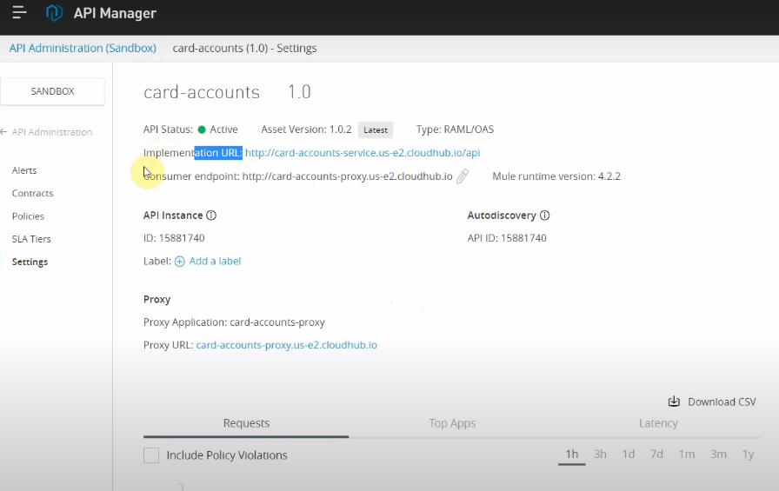

Now we have Created the Proxy but still we did not apply the Policies on top of it. If we did not apply policies then any one can hit the Service.

In exchange we can change the Mock response to Actual SandBox then Our service will get call the Actual Service deployed in cloud.

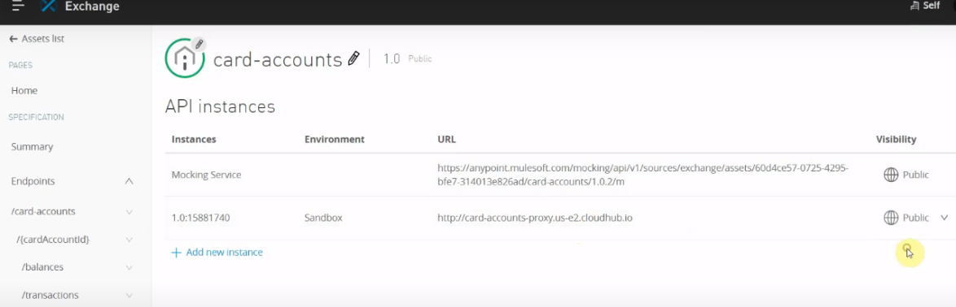

**We will apply policies now:**

API Manager -> Project -> Version [1.0] ->

We can create SLA’s for Rate limit.

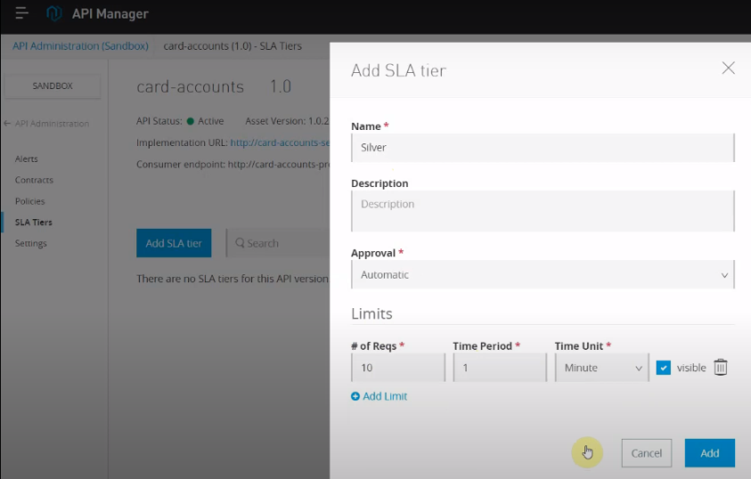

Distributed Dining of service[DDOS] we will achieve using Rate limit. We can configure the Rale limit based on the Customers Silver ,Gold so on….

Silver = 10 requests for 1 min

Gold = 100 Request for 1 min

Approvals we can set as Auto and Manual. If Manuel it will go the Admin for Approvals and we will get the separate Client_id and Secrets .

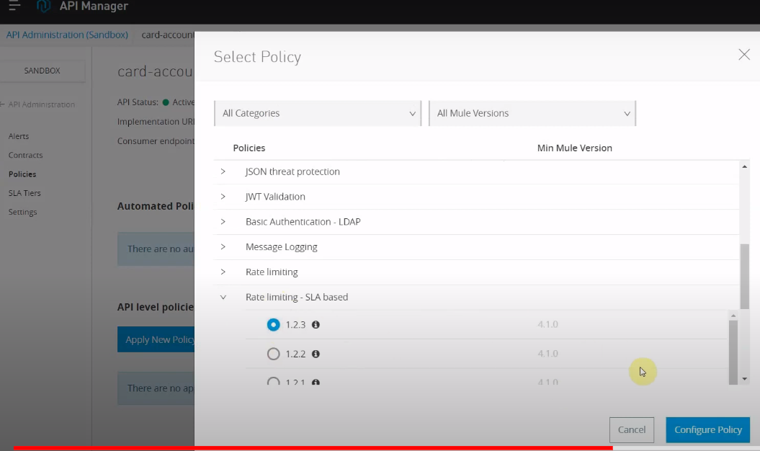

After adding new Policies, we need to redeploy the application always.

In Exchange we have developer portal and we can Create Application with Rate limit options like Silver ,Gold .. ETC

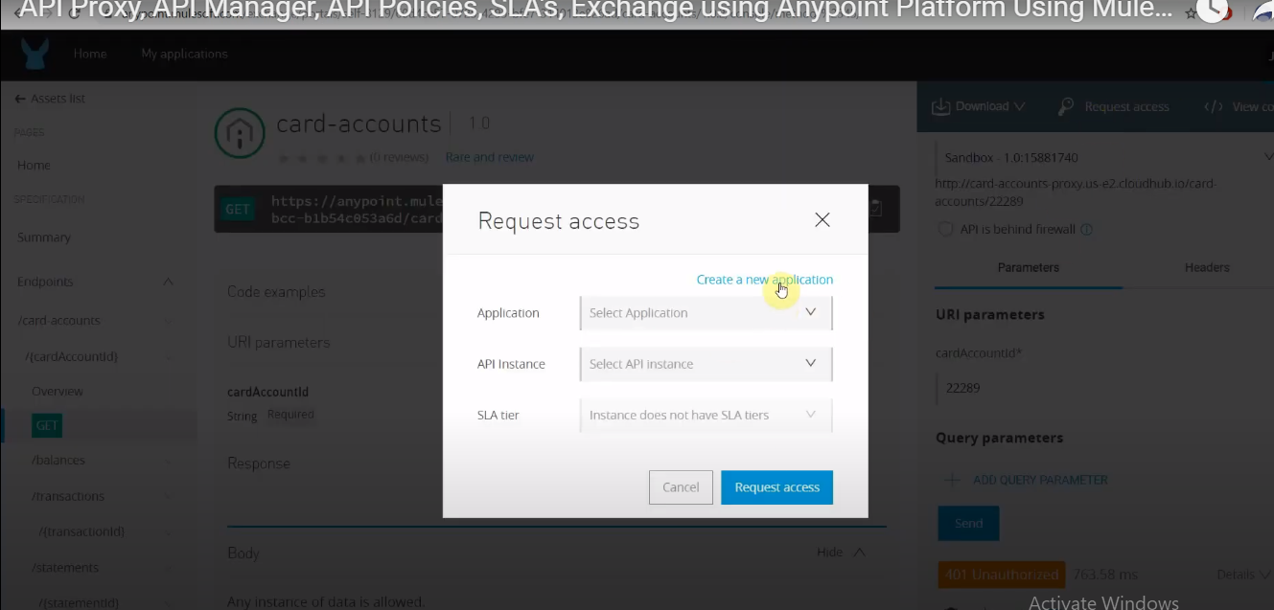

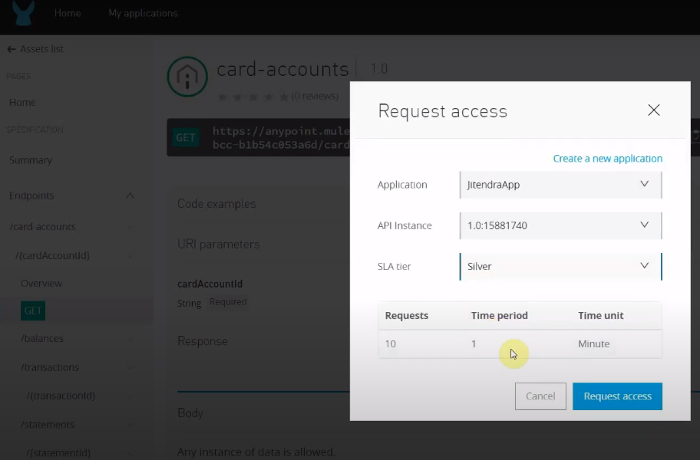

Will get new Client id and Secret::

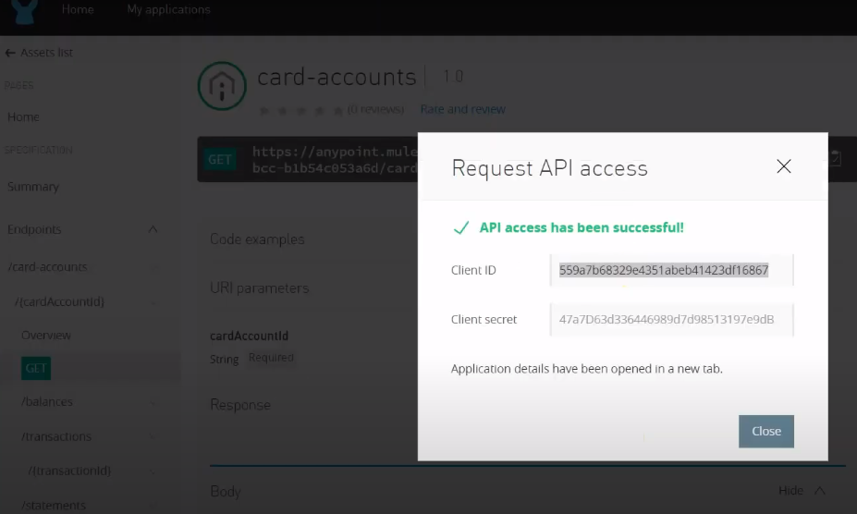

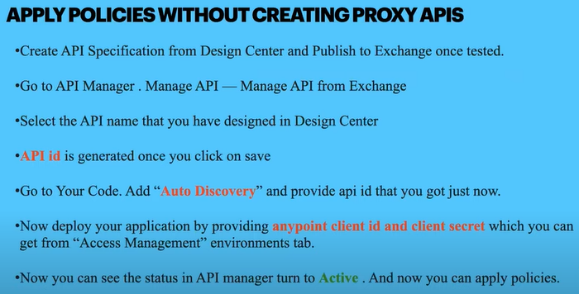

**Various Policies::**

1. **IP Block List:**The requests coming from the Clients need to block.
2. **Rate Limit :**To control or Limit the Request load .
3. **Basic Authentication:** Username and Password need to provide.
4. **Cross-Origin Resource Sharing:** If I want to publish the end Point to UI[JavaScript,React JS] then we need to enable Cross-Origin Resource Sharing.
5. **OAuth2 :**It is Client Server Architecture. Client will give us token and we will use it to validate using Server.
6. **ClientId Enforcement:** Using Client_id and Client_secrets we can provide the Security.
7. **JWT Tokens:** We will hit the Authentication server and get the JWT tokens to Access Endpoint.

**67.How to Avoid Auto Restart or redeploy server in Mule?**

We can add **autodeploy =false** in runtime manager properties file.

**68.How to Create and use Different Env files like DEV,QA,PROD ..etc in Mule?**

Create dev.properties,qa.properties,prod.properties and in runtime manager properties file mule.env = prod if we give then it will pick the prod.properties file.

**69.Why Target Payload and Variables?**

1. Mule 4 **message** contains payload,attributes,Variables and Exception Messages
2. Payload and Attributes will not available to next Connector and will get Expire.
3. We can use the Target payload to store the input payload data for doing operations in next component
4. We can use set Variable for storing the Outcome of the Current Connector
5. It will be same as for the sub flow also available if we set to Target Payload.

**ForEach and ParllelForEach:**

1. Whatever the payload we have before the for each that will not change by for each scope after the **foreach** completion the payload will remains same for next connector.
2. We should always declare **array variable [Accumulator] before outside Foreach** to store the Enriched data.
3. We will not get the response of **Parnell Foreach** Response outside of it.
4. In Foreach Loop also we can declare the **Batch Size**. In Foreach there is a batch size and then we can set the size.
5. ParallelForeach every record it will consider as separate Event to execute
6. If there is any error occurred inside of parallel foreach then we need to handle errors and use **On Error Continue** otherwise no records will get execute.
7. Always Parallel For each will consider **max concurrency** based on the System Cores.
8. See below image for Cores.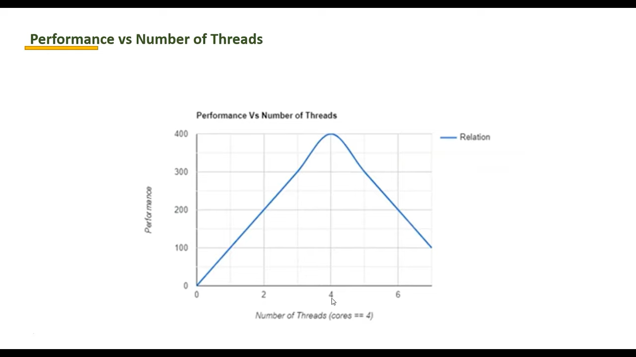

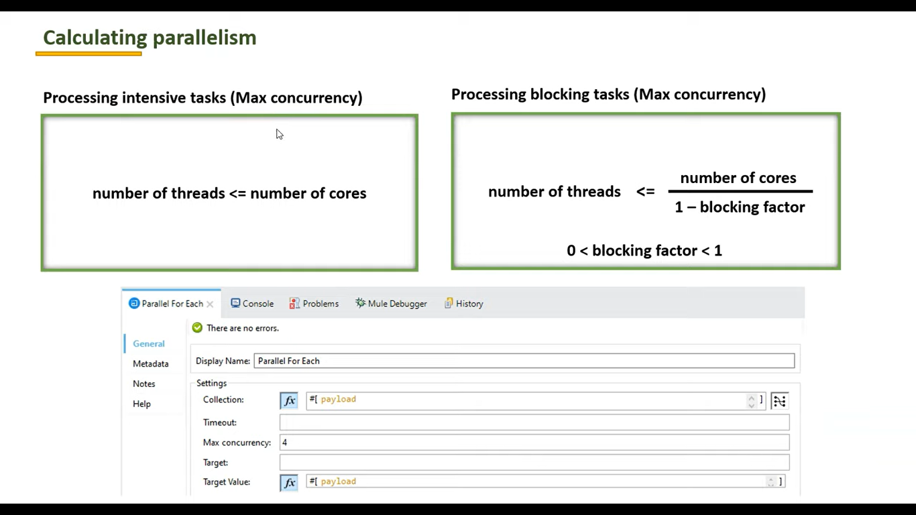

**Error Handling in Batch Job:**

1. Suppose we are processing 100000 records and 30000 records got failed because of data issue or DB down then the track trace will not print 30000 times in mule and mule will handle it is a excellent way and only once it will print the Track trace and provides the Total records like 30000 .
2. We will get the count of failed messages but we won’t get the messages and which messages got failed.
3. We can make the **Acceptance Policy = Only_Failures** then we will get the Failed records to next Batch job and we can put in DB to process further or Stored into a failed Directory as CSV file.
4. We can get the records using the error handling in Mule.
5. In Mule we have

Max Failure records = -1[Process will never stops irrespective of Failures]

Max Failure records = 10 [If 10 record failed then process will get stopped

**Cache in Mule:**

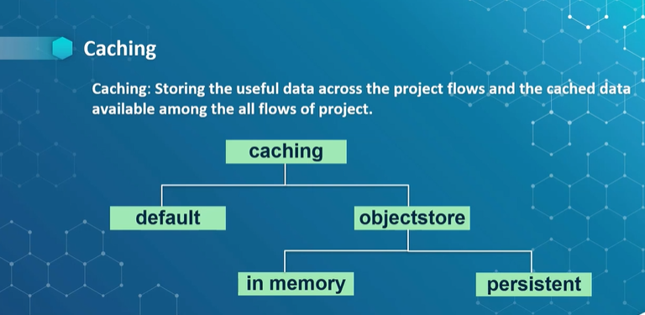

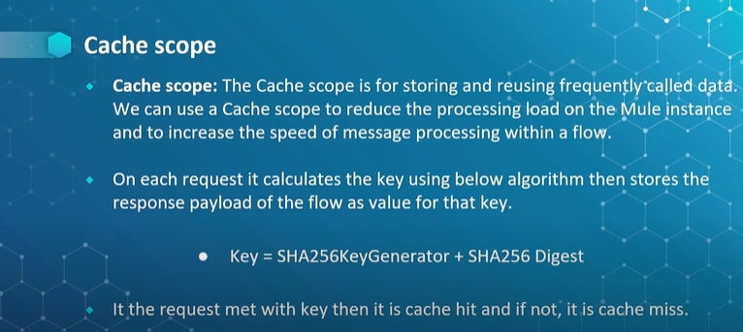

**Object Store:**

1. For Persistence Store of cache data, we can use the Object Store.
2. In cache scope we need to select **REFERENCE TO STRATOGY** instead of **DEFAULT STRATEGY**
3. If we want to go for Key generator then we must write java code.
4. We have **Filter** also for we do not want to cache some specific data.
5. Below is the Conf for Instead of default key generation we can use our own key.
6. The default cache will be available only the Current flow and it won’t be available for Other flows. It will be cleared when the Ram is cleared.

**The three types of Object Store are:**

[**https://help.mulesoft.com/s/article/The-Different-Types-of-Object-Stores-Explained**](https://help.mulesoft.com/s/article/The-Different-Types-of-Object-Stores-Explained)

1. Anypoint Object Store V2
2. CloudHub Object Store V1
3. Mule Object Store
4. Anypoint Object Store V2

**1.Anypoint Object Store V2 :**

Object Store V2 is the latest version of CloudHub Object Store. This is a Cloud Service that is external to the Mule Application. It is only used by CloudHub deployed applications.

**Use-Case:**

CloudHub deployed applications that need to persist key:value data in a simple database.

**2.CloudHub Object Store V1 (OSv1)**

ObjectStore V1 is the original Cloud-based Object Store for CloudHub applications. This version is now deprecated and will be End-of-Life (EOL) at some time in the future. The end of life date is not yet announced, but customers are encouraged to use OSv2 when possible.

**Use-Case:**

CloudHub deployed applications that need to persist key:value data in a simple database.

**3. Mule Object Store**

Mule Object Store is the original on-premise based Object Store that is part of Mule Runtime.

**Use-Case:**

Mule application that needs to persist key:value data to be referenced by different flows or for a different mule event.

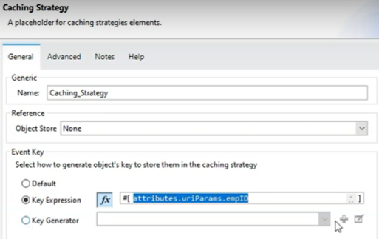

Object store is used for the persistence store for use the cached data for multiple flows.

**Scenarios to use Object store:**

1. Suppose we need to read some lookup data from Db and keep it available to All the flows then we can put one server startup in Object store and We can read the Data from Object Store.
2. We can store **access tokens**to Object store For OAuth 2 access and suppose key is valid for 1 hr then we can keep Time To Live to 1hr and then after 1 hrthe Object store will clear the token and get the token from client and keep it in Object Store and read from there for next 1 hr and follows the same.
3. We can achieve WaterMarking concept using Object store.

**Oauth2 with Object Store:**

1. We must call the Rest call which have the OAuth 2 Access permitions.
2. We must pass **Barrier token** to the service for this we need to hit client service and get the barrier token always.
3. If we must call the rest call 10000 times, then we have to hit the Client service always and get the barrier token. But this is not the good idea to call 10000 times the client and getting the token.
4. The token will expire every 1 hr because of that we cannot hard code the token.
5. For this we can create the Object Store to store the Token and we will set time to live for 59 mins.
6. 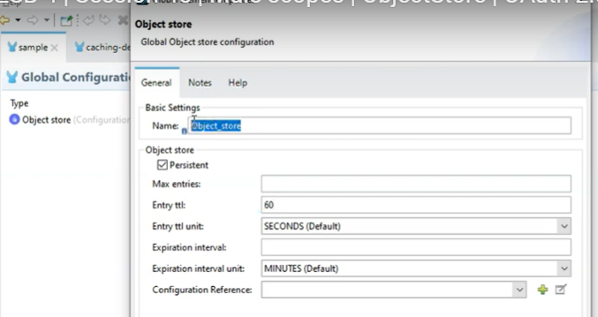

Suppose we need to call rest call which is having the OAuth 2 permitions then we can call the sub flow Retrieve OAuth 2 Access Token and it will call Choice router -> Check Is Empty(Payload) ->if the Token is empty then get from the Client API call and store to Object Store -> Set the Access token which is present from the Object Store.

See the below Diagram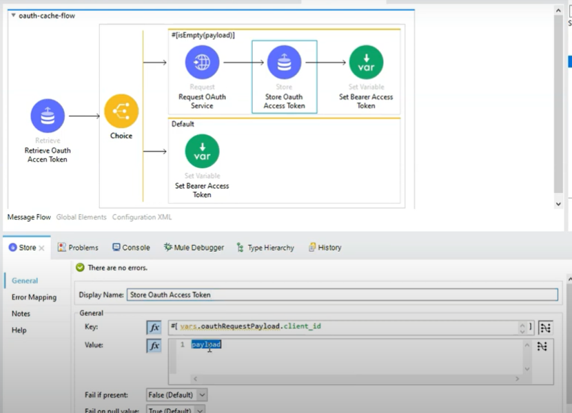

We have Cache Object Store in APF Runtime manager, and we should configure the**V2 to store** the Data to Object store.

**Water Marking with Object Store:**

1. Suppose we have Ground DB and we have to migrate to Cloud DB then

We must migrate history date and live date from old db to New Cloud DB.

1. We use Water Making with Object Store to fulfill this requirement.
2. Always We use primary key for Water Marking Column
3. Watermarking will support only numeric values.
4. If we have 2 primary keys like id and email then we have to go with id because water marking with Object store will support to numeric only.

**Global Error Handler:**

1. Global Error handler will be defined in one Project and We can use it among all the Projects.
2. We should identify all the error from our project may raise and we will keep it in Global error handler.

**Error handling in Global, main and sub or private flow:**

**If error happened in Sub or Private and not handled in the main flow:**

**1.on Error Continue:** It will stop the current flow and Continue the main flow

**2.On error Propagate:** It will raise error to calling flow

**If the Error is handled in Sub flow and also main flow :**

**1.on Error Continue:** It will stop the current flow and Continue the main flow

**2.On error Propagate:** It will raise error to calling flow and propagate to main flow Error handling.

1. If the error handled in Sub,main and global then it will propagate until main and return from there it wont go to global.
2. If the error handles in sub flow and global but not in main then it will go to Global and returns.

**Note:** If any errors which are handled in Main flow then itwont reach the global Error handling. If the error is not handled in Main then only it goes to Global.

**AnyPoint Platform:**

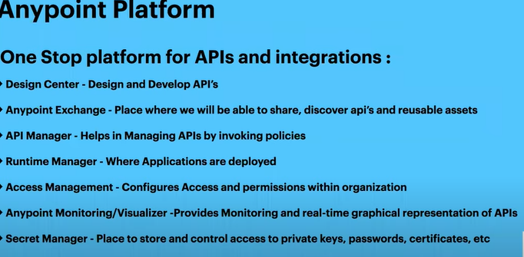

**Mule Deployment and Policies::**

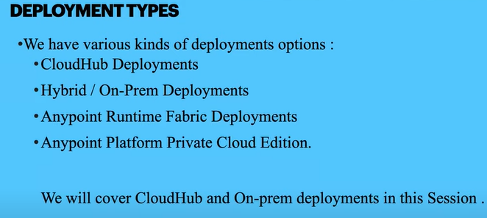

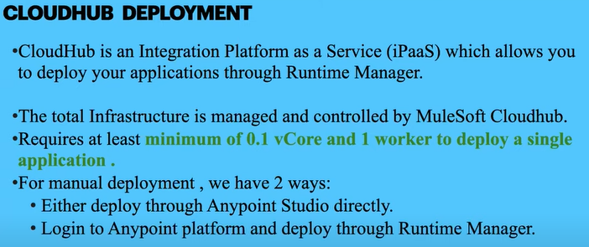

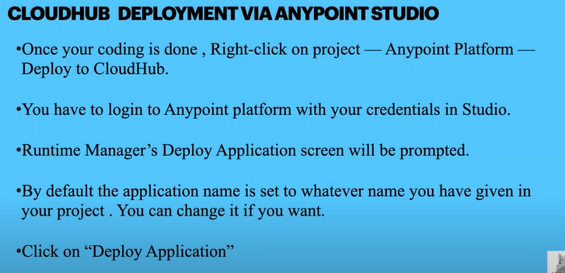

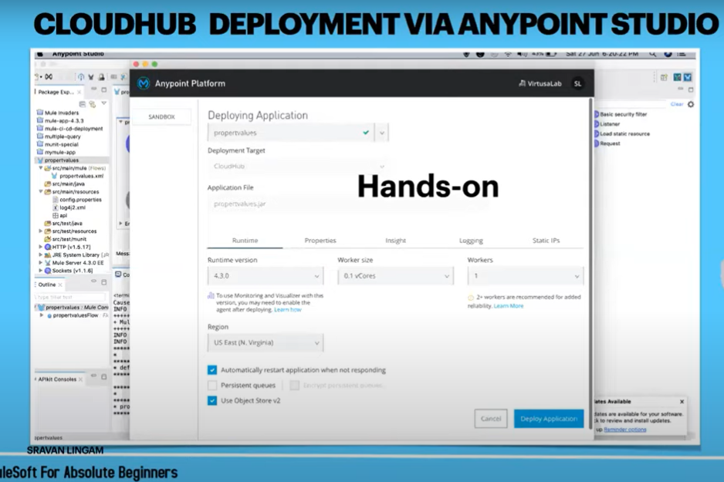

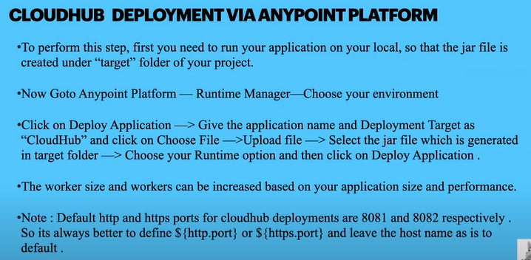

**70.How to consume messages from Topic parallelly?**

**1.Kafka Listener:** to Consume Messages from Topic:

**71.What is APIKitRouter?**

1. It is used to route the request and validate the request.
2. If we want to restrict the Header parameters, Query parameters other than added from RAML.
3. It is Used for the service as Rest or SOAP.
4. In Mule 3 it was embedded with Runtime but In Mule 4 it is given as Plug in.
5. We can Changes the API Kit Router version using POM.XML in Mule 4 but Mule 3 we cannot.
6. It will do Header and QueryParameter Validation Also but we need to Enable to validations for Header and QueryParam.

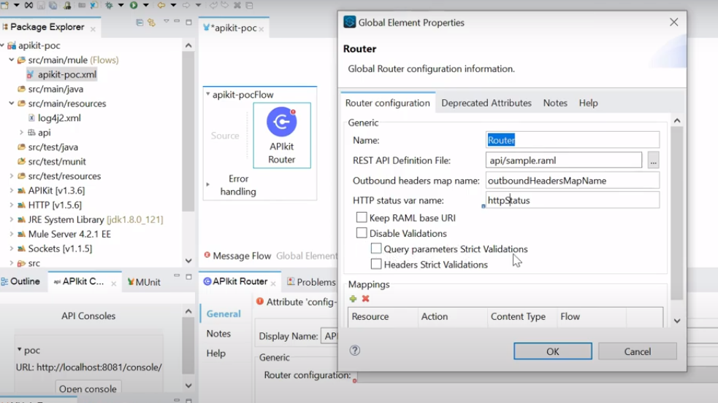

**72.API instance ID is same for all the env or not?is it same for dev to qa to prod?**

1. API In stance Id is same as Auto Discovery Id and it is different for ENV.

**73. How to deploy in on-prem servers?**

1. On-prime deployment is like Manuel setup of Mule env and it will be on ground not on Cloud.Wer cannot apply Mule Policies to Applications which deployed in On-prime
2. Download the Mule Runtime server which is provided by mule and start the server.
3. Build the project and keep the .jar file in to **App** folder.

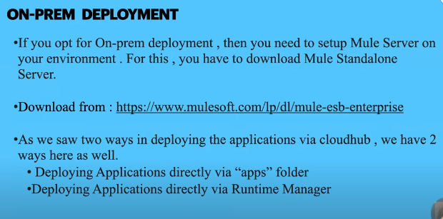

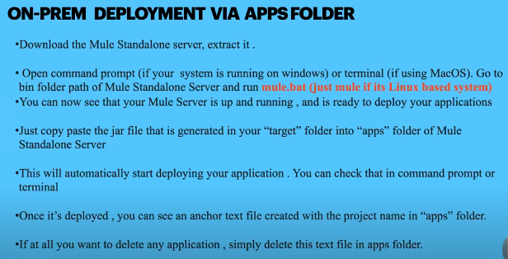

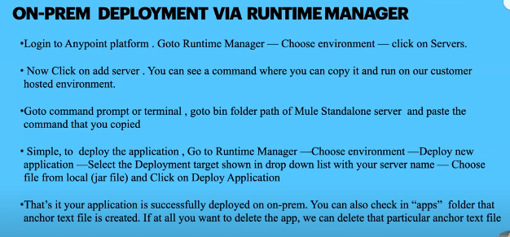

**75.How to develop custom connector?**

[**https://www.youtube.com/watch?v=9Y32EGpTYtk**](https://www.youtube.com/watch?v=9Y32EGpTYtk)

If we have to connect new database and Mule don’t have existing connector then we will go for Custom connector:

**REST Connector with GET :**

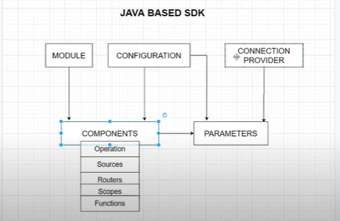

We have Mule SDK

1.Go to any location like c:/custome

2.run the below command:

Mvn borg.mule.extentions:mule-extentions-archetype-maven-plugin:1.2.0:generate

3.It will ask few names:

a.Name of Extension

b.groupId

c.ExtentionsArtifactId

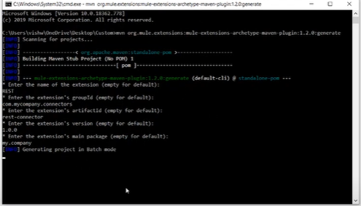

Project will get Executed successfully and import to AnyPoint Studio:

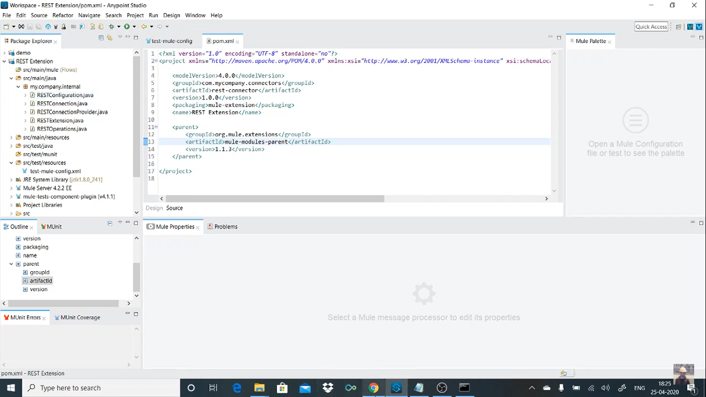

1.Extentions

2.Configurations

3.Operations

Once the Code have done then need to clean and install the project using

MVN clean install

Now in Local repo the jar is created with GroupId,ArtifactId,Version

We can add this to our mule project and we can see the custom Connector in Mule Pallet

**Code :**

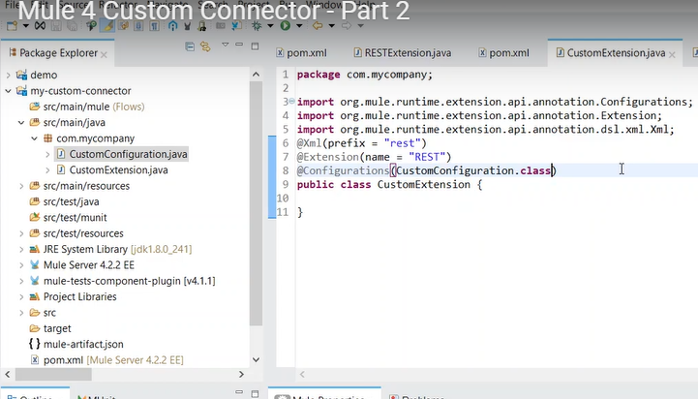

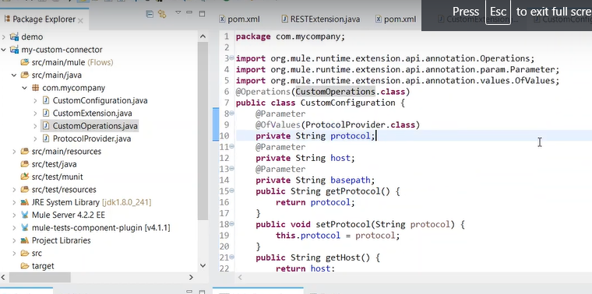

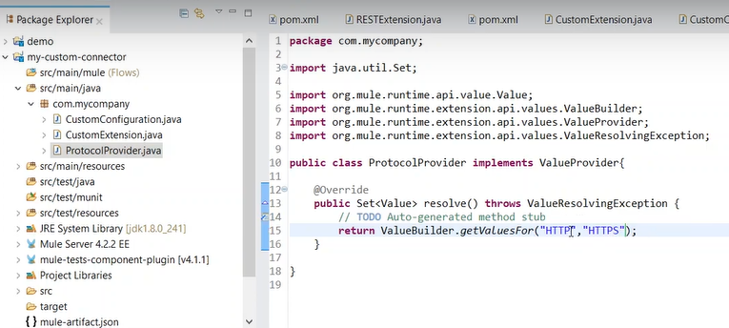

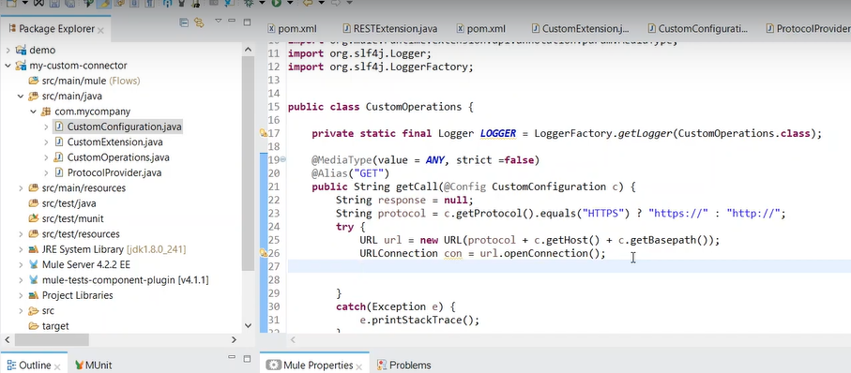

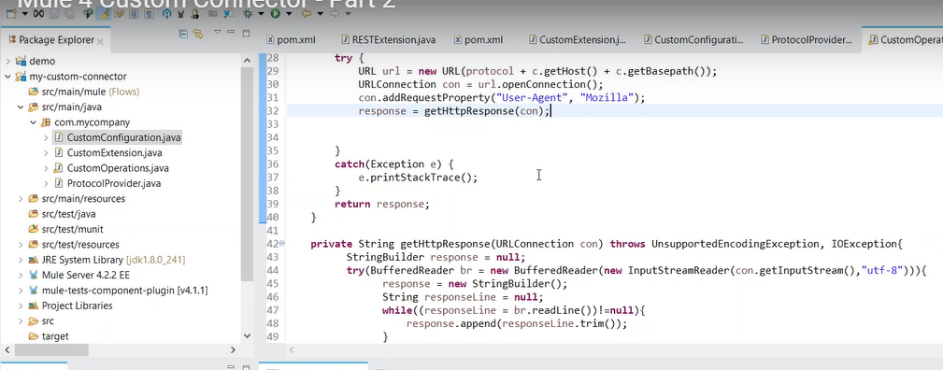

File name and Icon Name both should be same:

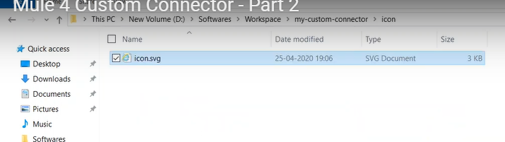

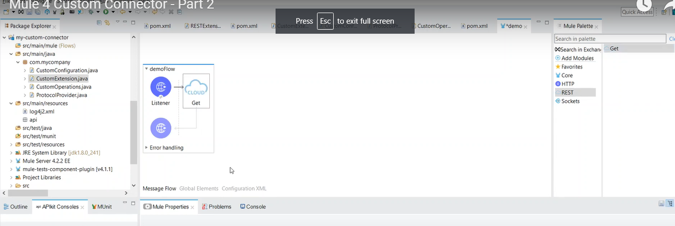

**76.CI/CD Pipe line ?**

It is a process of Automation of Application Build and deployment.

It will avoid the deployment time.

We can achieve it using Jenkins.

We need to install JAVA,Maven,Junkins,Git to active CICD .

**Size of each worker; one of the following values:**

1. MICRO (default; 0.1 vCores)
2. SMALL (0.2 vCores)
3. MEDIUM (1 vCore )
4. LARGE (2 vCores)
5. XLARGE (4 vCores)
6. XXLARGE (8 vCores)
7. 4XLARGE (16 vCores)

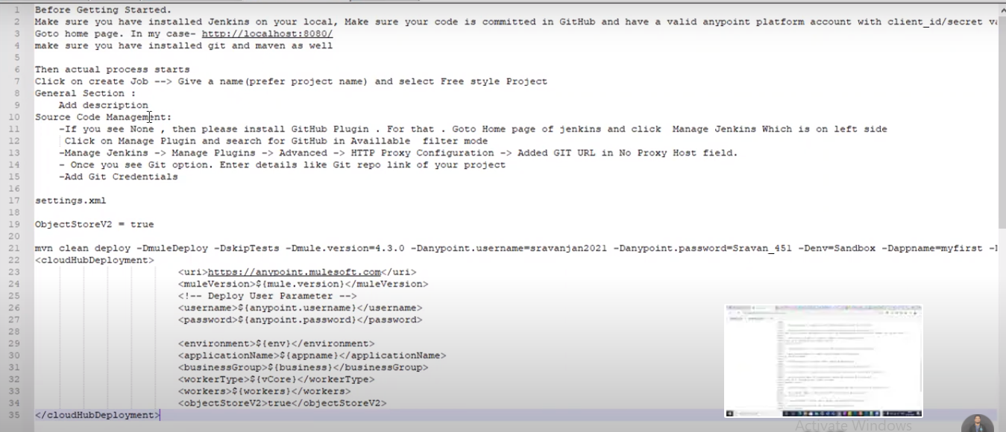

1. <mule.maven.plugin.version> is used to deploy application using Junkins
2. This pluin will take all the arguments given below in pom.xml as place holders and runtime when we will build and deployusing Jenkins it will provide the values to the Place holders.
3. In the maven plugin we need to provide the all the values w e will select from the Runtime Manager.
4. URL,UN,PW,MuleVersion,ENV,APPNAme,BusinessGroup,VCore size,Workers,V2 =True
5. In Junkins job we have to give the below values

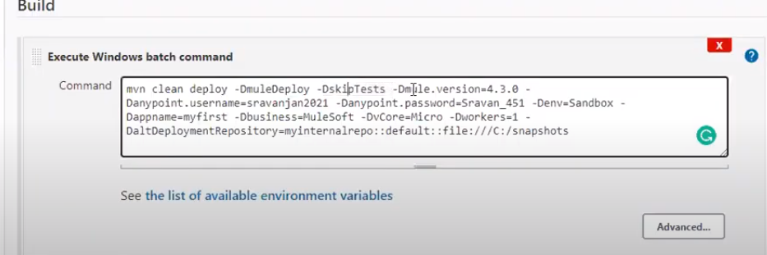

We can define the .jar file location in Settings.xml for reading the file from junkins dynamically for deploying

**Pom.xml:**

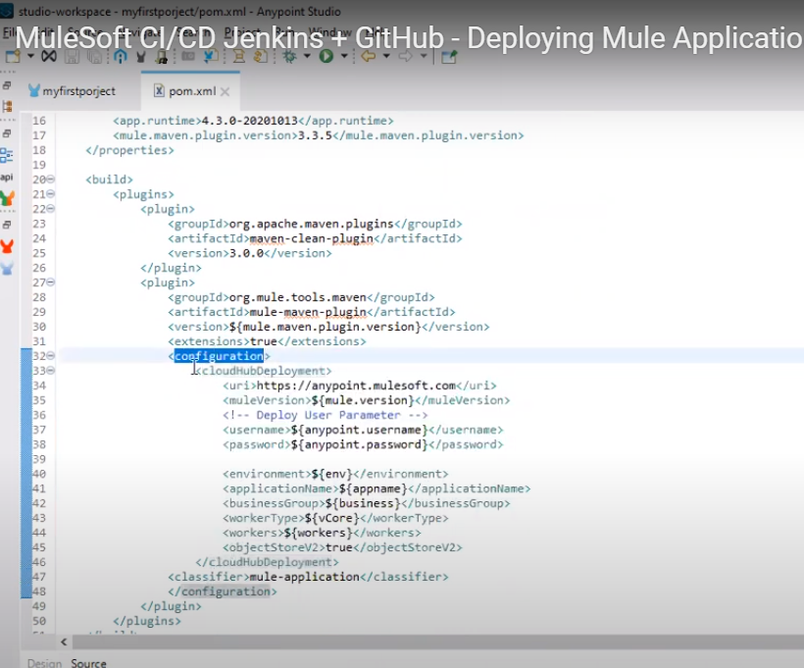

**69.How to write Munit ?**

**MUnit:**

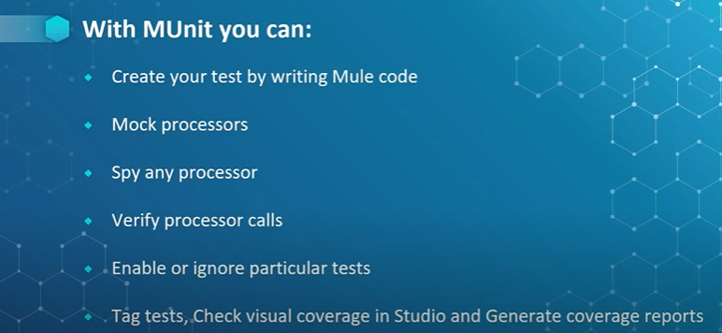

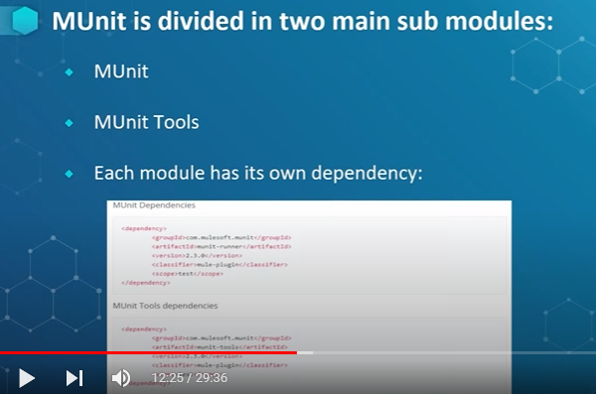

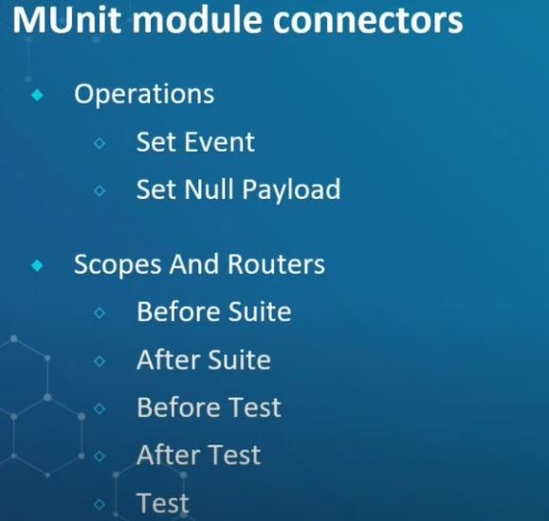

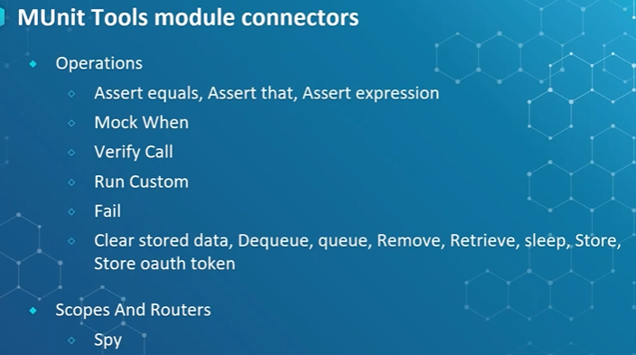

**Test:**

We have 3 sections in test

1. Behavior: Mocks and spy.
2. Execution:It is used to trigger to flow that what ever we want to test.
3. Validation: We assert the Actual and Expected

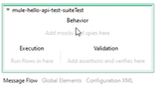

**We have 3 different types of asserts:**

**1.AssertEqual:**It will check the 2 strings are equals or not

**2.AssertThat :**Here we can use the predefined methods to compare the Input

**3.AssertExpression :**here we can write DW script to check the Input data.Some customized logic also we can do here and also predefined method also available here.

Note: Mostly we will go with Assert That if the requirement is not suitable then we can go with Assert Expression

Go to main flow and right click and then create blank test for this flow.

Src/test/mule /we can see blank test will be created

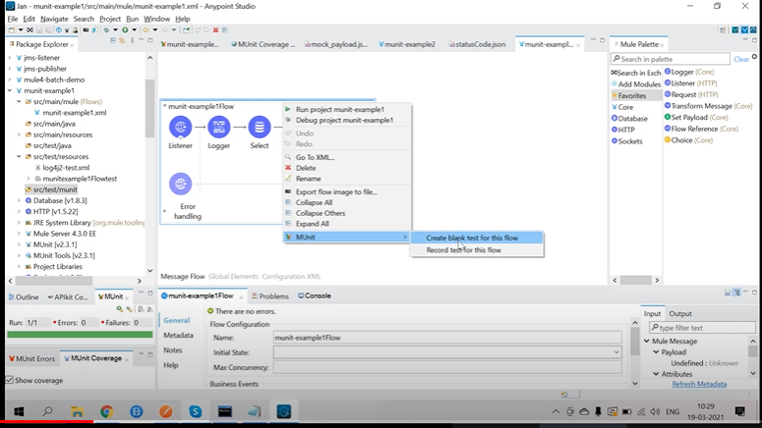

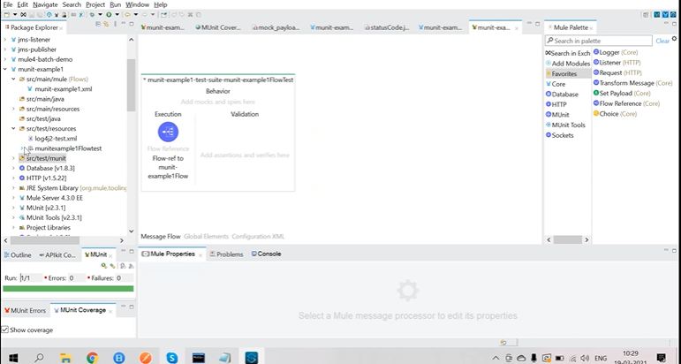

**Object Store V2** provides the **Distributed cache** with API. We can pass the **ClientID** and **Client Secrets** to get the Object Store for getting the Value while passing the key

1. Suppose the record stored in Object Store at 10:30 PM
2. TTL : 1 hr
3. Expiration Interval: 30 m
4. Cache will get expire on 11:30 AM
5. Always TTl > EI
6. EI is a thread to identify the expired cache elements and remove it from cache.
7. If we go to **pick processor** then we can see the all the components in the flow for mocking

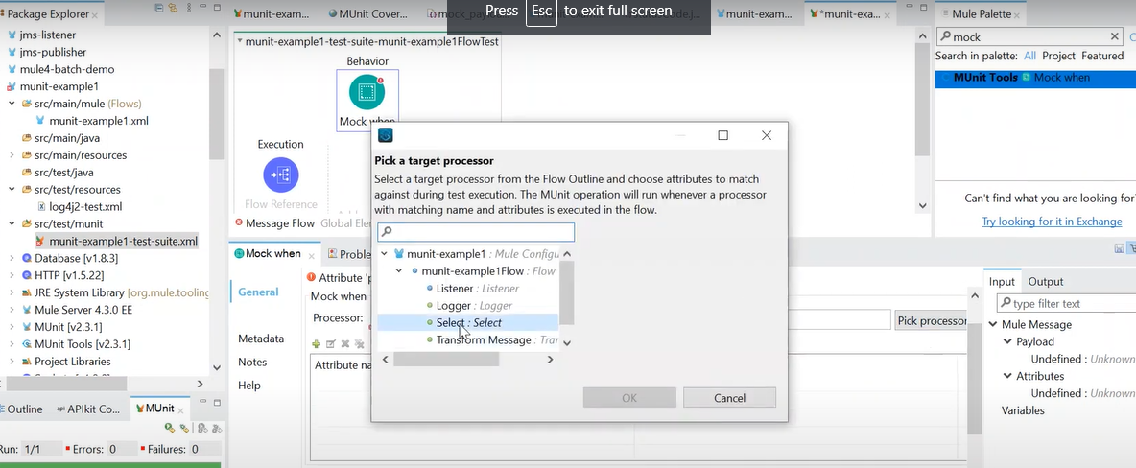

We should use **select** component for mocking and Configure the mock response payload ,varables,Attributes,Error.

We can keep the Resp payload in a **xml/json/dwl** file and read from there to Payload of Mock component using below expression. Also media Type and Encoding we need to select

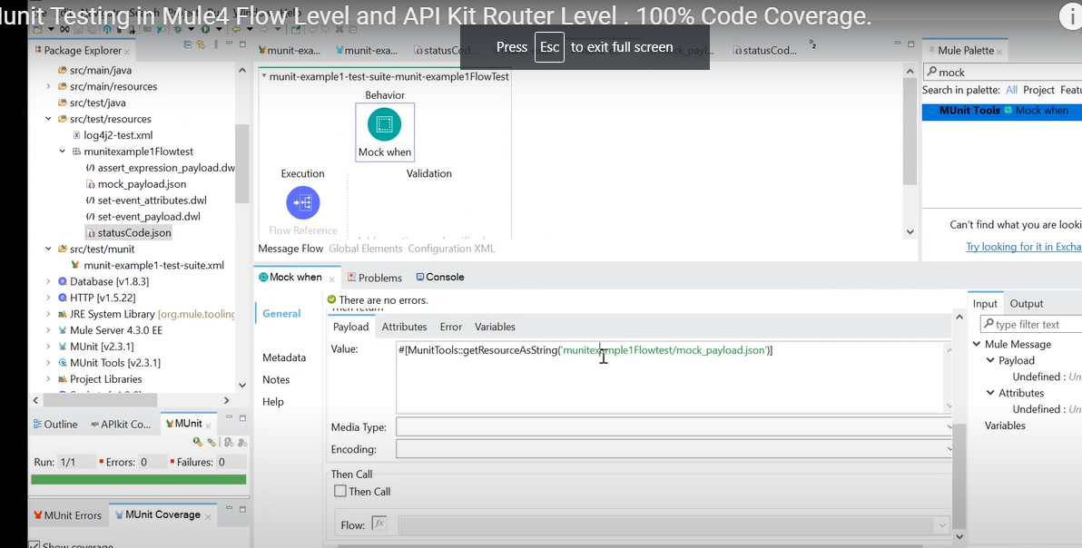

**Paylaod like in the screen shot:**

#[MunitTools::getResourceAsString(‘mainExample1FlowTest/mock_payload.json’)]

**Added Attribute as Status Code:**

#[MunitTools::getResourceAsString(‘mainExample1FlowTest/statusCode.json’)]

Then We can compare the Actual and Expected Results. If both matches then testcase will pass or fail.

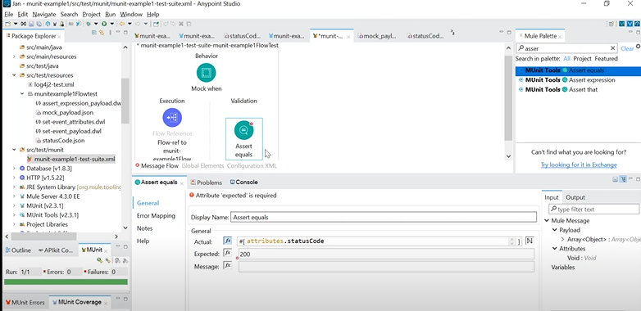

**Code Coverage:**

We can see the Actual flow components which are having the **Tick mark** that all got covered with the test case.

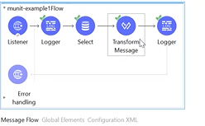

**Munit with APIKitRouter:**

Suppose if we create the **MUnit** from **APIKitRouter** then it will create all the testcase for the API’s means Negative and positive test cases.

All the Error codes related test cases also it will create and keeps the Mock data in the **SCRAFFFOLDER.**

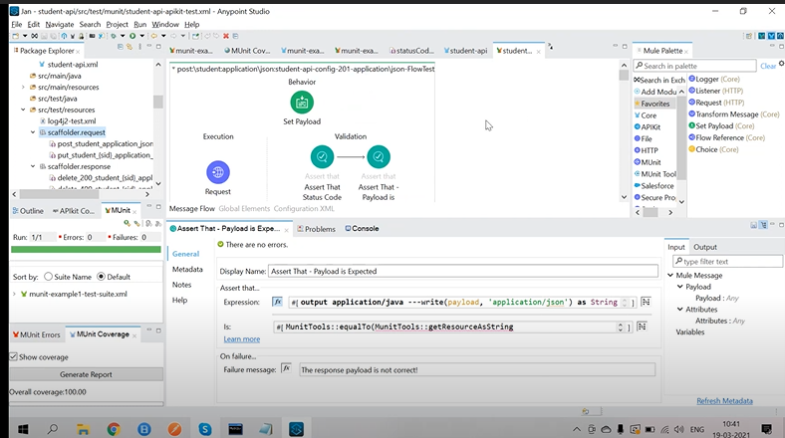

**70.Validation Framework in Mule 4?**

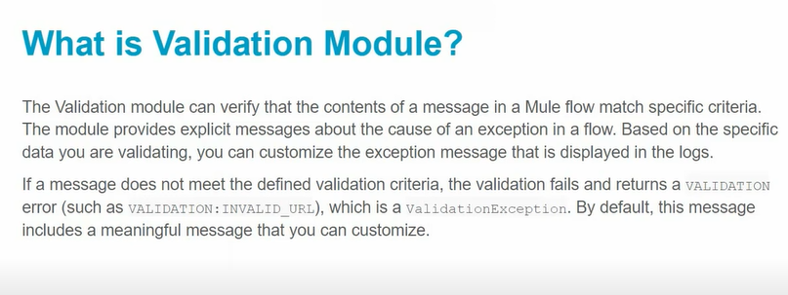

In Mule Pallet we can see the Validation Module and under that Is Not Null …etc

1. IS Not Null
2. IS Null
3. Is Number : we can validate it is integer,float,Double,Long and also we can set conditions like min =10 and max =100 in the Is Number Components.
4. Is IP
5. Is URL
6. Is Email
7. Validate size
8. Is false
9. Is Time
10. Is true
11. Is False
12. IS blank String
13. Is not blank String
14. Is Blank Collection
15. Id not Blank Collection
16. Any [we can drag any and on top of it drag **is number** and **validate size**] any one validation should success
17. All [we can drag any and on top of it drag **is number** and **validate size**] Both need to get success

The max IP address will support is 255.255.255.255

Finally if the validation failed with the above validation Components then we will throw error with matched error type.

**71. How to work with SFTP in Mule 4?**

**We can give below conf details for SFT or SFTP:**

1. Add the SFTP – List Module

**SFTP Configuration:**

1. Directorypath
2. File name pattern .xml/.txt / …etc
3. Host,port,un,pw and Identity file[Public & Private key]
4. Using Putty we can generate the Public and Private key
5. After that we have to save the both.
6. **Private_ket.ppk** : It is used in our Mule Application in SPTF LIST Connector
7. **Public_key.cert** : It is going to use in SFTP Server

**How the hand shake will happens from Client to server:**

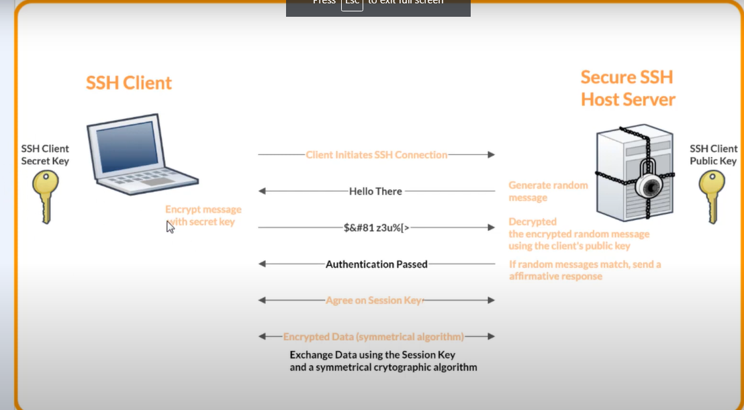

**Recursive =** true then we can get the all the file in root and sub directories otherwise will get only from Root directory.

Suppose we are reading cml/json file the if that does not contains valid data it throws error like **“Unexpected End-of-fine in Prolog”.**

**71. How to process millions of records with CSV?**

[**https://www.youtube.com/watch?v=7CgZZqKoHLQ&ab_channel=sivathankamanee**](https://www.youtube.com/watch?v=7CgZZqKoHLQ&ab_channel=sivathankamanee)

**1.Scheduler :Read the file and then split the file into smaller size like 10000**

**2.FTP[On New or Update file] : Read the Files and Process using Batch Process. Select Auto Delete =true then processed file will get deleted.**

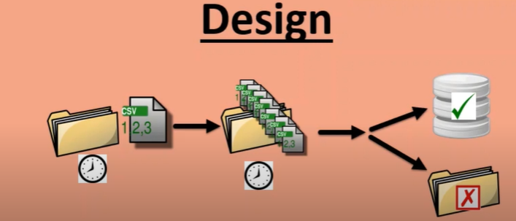

**How to configure java class and method in Mule.**

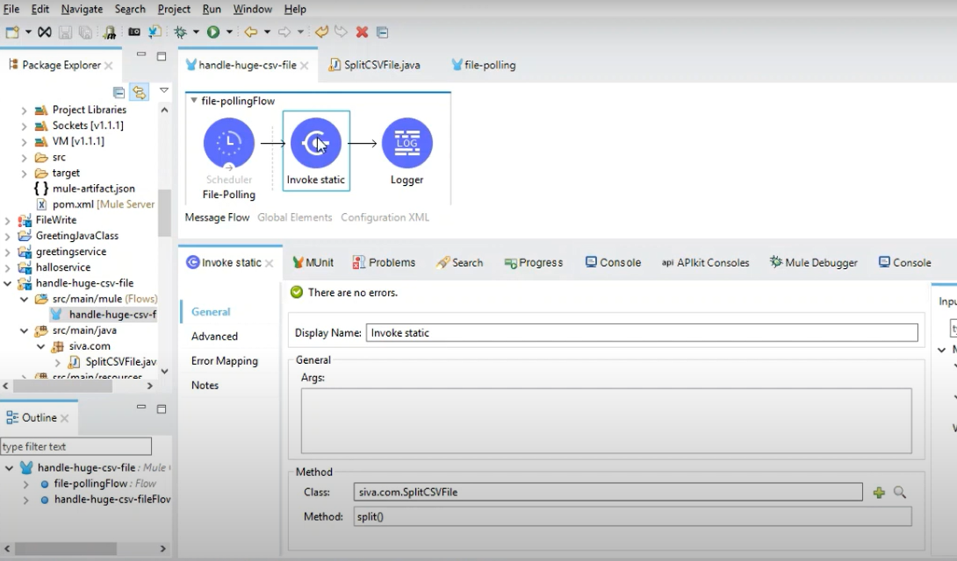

**Java code to process file and create smaller files**

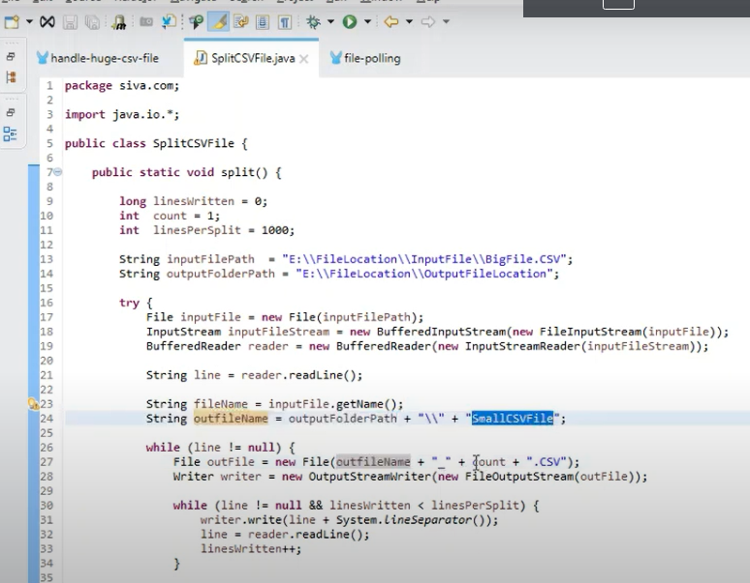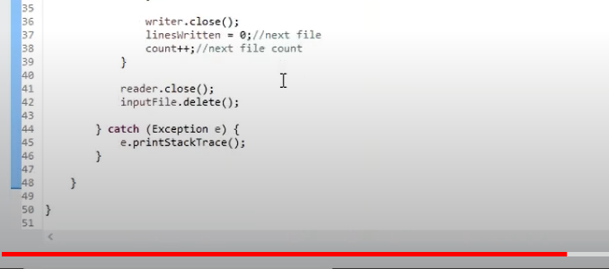

When we are processing we should not put logs inside it .It will cause performance issue.

**73.Batch Process Realtime example?**

[**https://www.youtube.com/watch?v=u8gWkRsan00&ab_channel=sivathankamanee**](https://www.youtube.com/watch?v=u8gWkRsan00&ab_channel=sivathankamanee)

Batch Job size > Aggregator size

Process Orders:

Batch = 100

Aggrigator = 50

SNO,OrderId,Qty,Price,CustId

1,111,3,20.50,333

2,111,5,25.50,333

3,113,3,20.50,332

4,113,5,25.50,332

**Take on new or Update file :**

1. Set the metadata of CSV
2. Connector Configuration with IP,PORT,UN,PW,Privatekey&&Pulich Key
3. Directory need to give
4. Auto Delete =true
5. Scheduled frequency = fixed Frequency with 5 sec
6. Drag the batch Process and set the batch Size as 4 but default is 100
7. In Batch Set we need to add some filer logic and then log it
8. In Aggregator we can give size 2 and Store into DB.
9. Suppose of there are any Error records then we need to take Batch Step 2
10. In Batch step 2 we need to choose **Accept Policy = Only Failures** and in Batch Job we need to select the failure records = 1

**Grouping the orders:**

1. Payload groupBy $.orderId pluck $

**74.How to handle more data with DB?**

We can use BulkInsert

**75.How to handle more data with JMS?**

We can use Kafka JMS Listener

**76.How to handle More data with FTP?**

We can use batch Process to achieve it

**77.How to design High Volume API in Mule?**

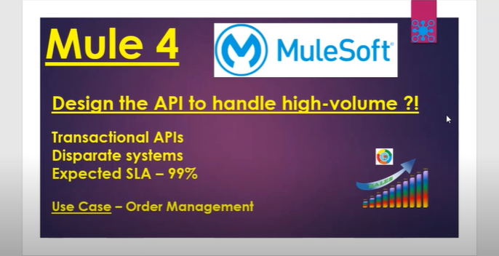

**Disparate Systems:** SAP will create order ,Mule will process and Salesforce will Give the Order details.3 System will involve in creating order.

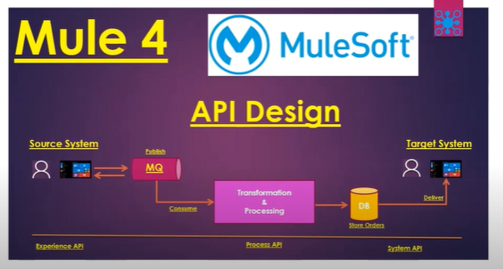

We can Use Apache Kafka Listener and Consumer to Process messages in Asynchronous Way

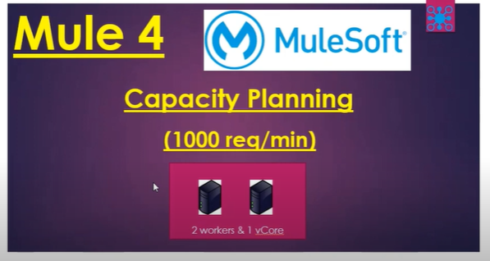

Max 1 vCore for 1 Worker we can use if we want to process 2000/1 Min then we have to go for 4 Workers with 1VCore

**80.How to configure and use Security Properties in Mule?**

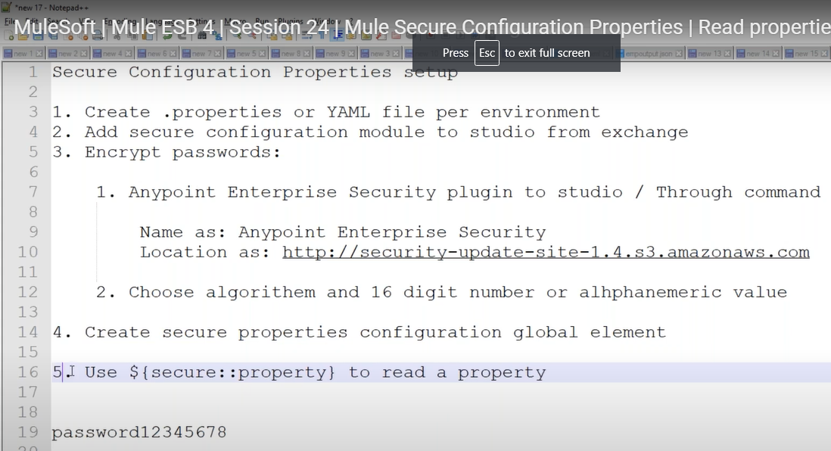

**Add Secure Properties Module to AnyPoint Studio:**

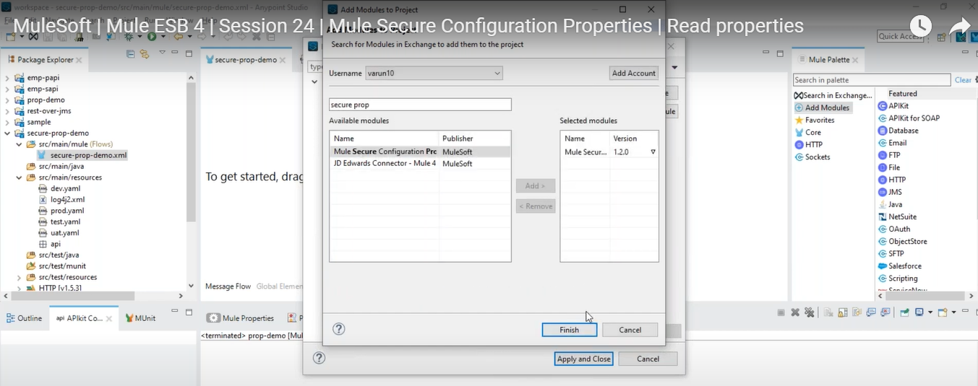

**Add AnyPoint Security Plug in to Studio.**

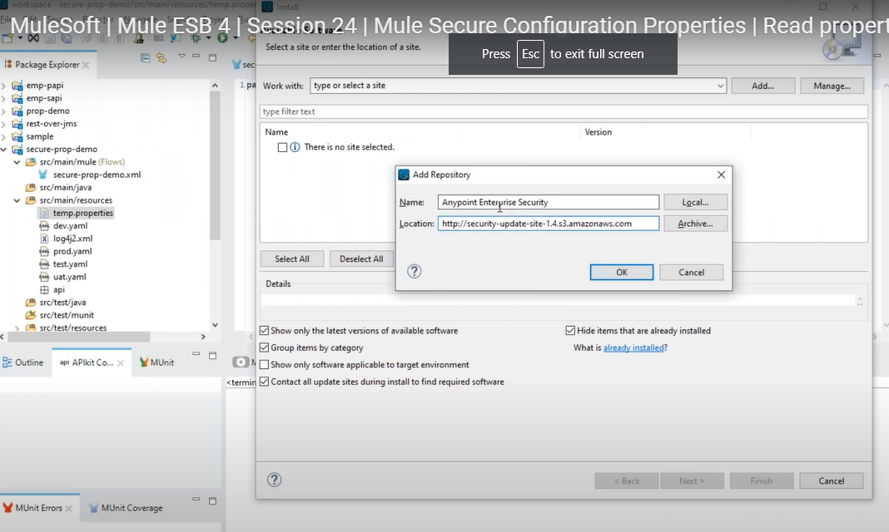

Then Edit the dev.yaml file with Secure mode and Select the Algorthm of our choice.

We can take the **Blow Fish** Algorithm for creating the Secure key and place into Dev.yaml file.

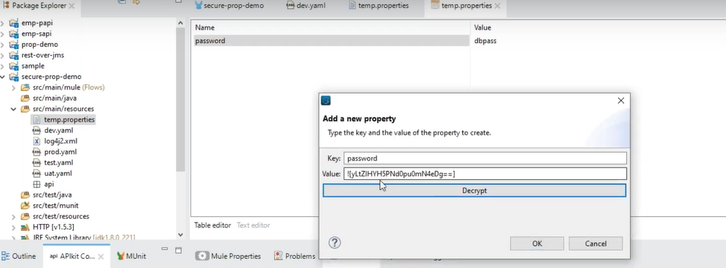

Configure the Secure Properties :

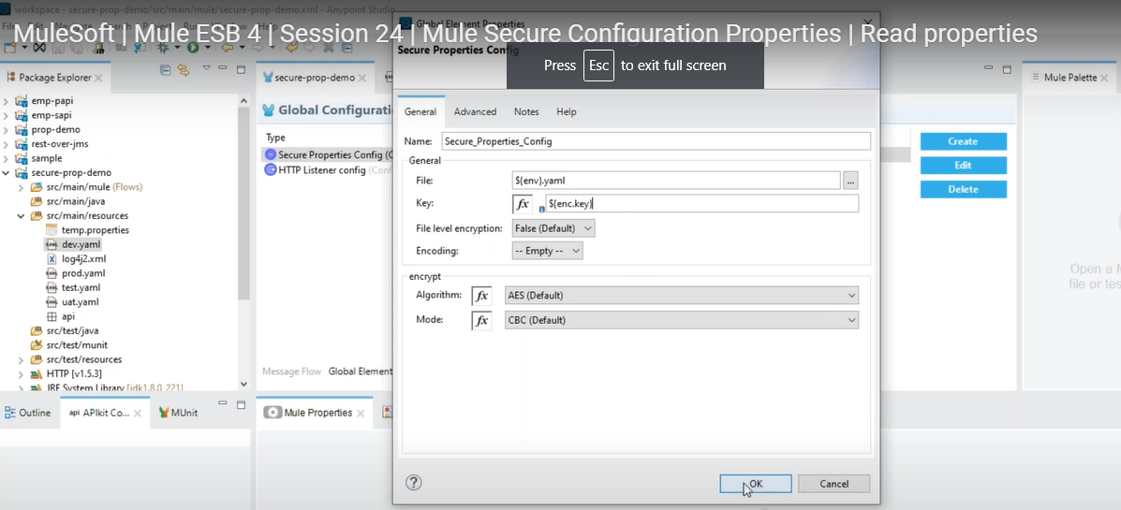

In the screen it shows AES but we use Realtime is **Blow Fish** .

We cannot hard code the password and Env file name .We have to pass from Runtime Properties file. Because it is different for Each ENV.

Now we have to Use the PORT in Rest Listener config ${Secure::http.port} if it the property is encrypted or not we have to use like this

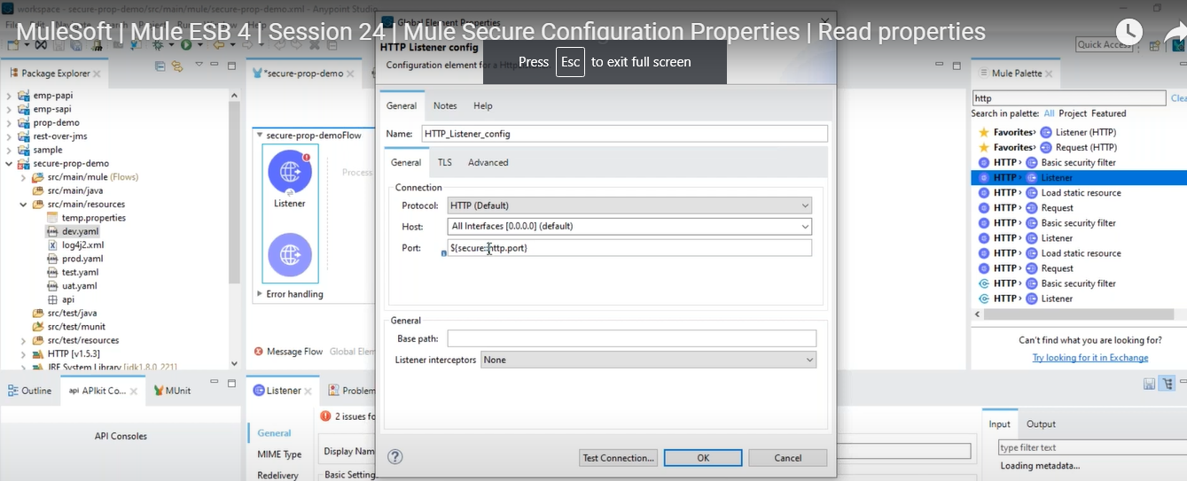

Below screen shows how to pass runtime properties from Studio.

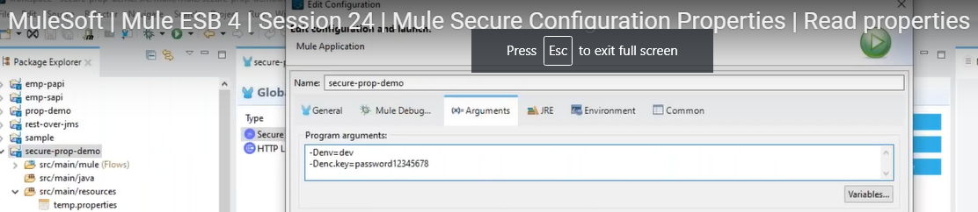

**81.How CI/CD: AWS Cloud? IN Volvo in JAVA?**

**We are using Jenkins with some customized UI Overseer for Build and deployments.**

We have 2 different build pipes like Infra and Application.

Application pipe will use the Code

Infra will use configuration related and which env,size of the Servers rlated,Security groups.

We will commit the code to git then it will create Build Pipe.

Webhook will intimate to Maven to build for every commit [Maven build]

Maven builds and move the code to Artifactory [Nexus repository]

DE will pick and create one temp EC2 instance for deploy the application for run the component tests.

If Component tests are success and then creates a image of it and do the Image Baking with Packer .

After it will create amazon image with all the code and configuration.

Then As per the Configuration file we must select the ENV qa,prod,test then automatically the details will get populated on screen then click on Launch.

The CE2 size is Like Small,Medium,Large,ExtraLarge ….etc

For securities we have adding inbound and out bound Rules those details we are specifying in the infra conf file.

We can mention the port and Ip detailsin YAML file in conf project for connecting to other systems or integration with other systems.

CloudFormation is used for this configuration.

After that the CICD will get the available IP and Apply the conf and Verifies it.

Finally we can click on activate then it will get activated

The down time is 1 minute for changing the IPS to new.

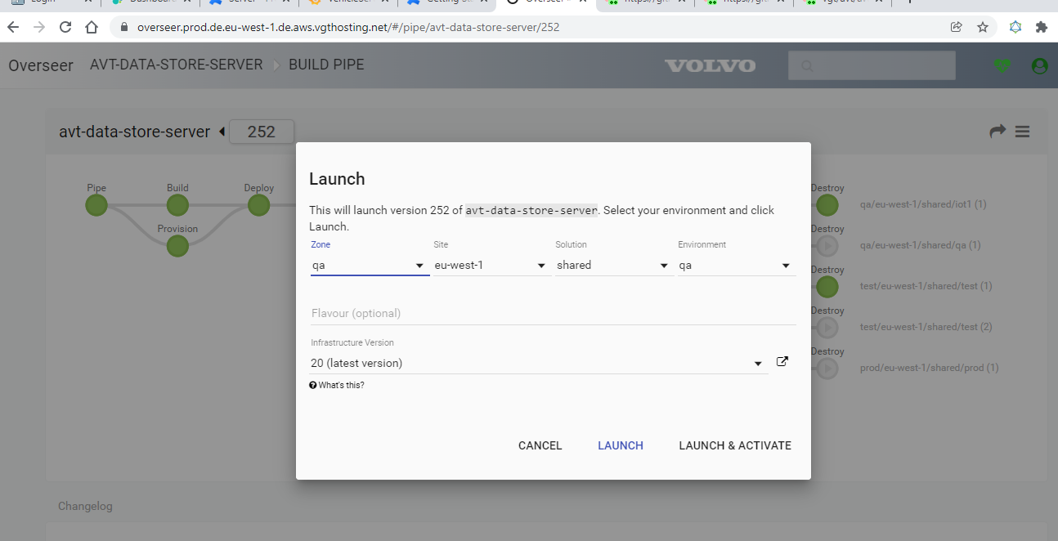

**JSON Payload Validation?**

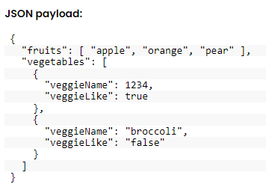

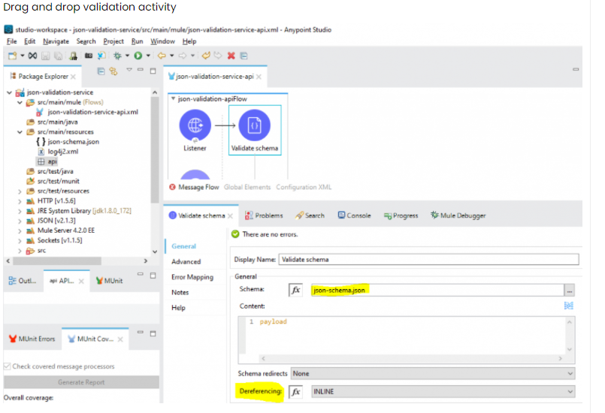

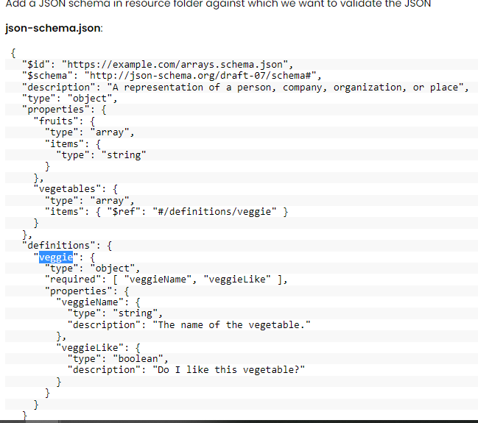

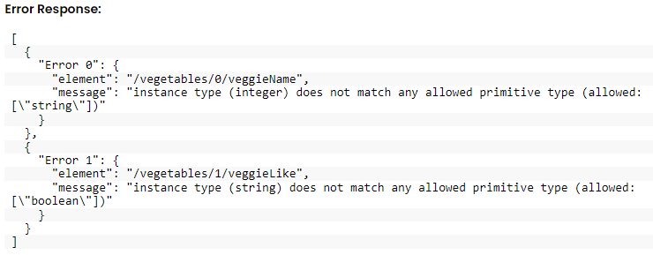

Tranformer logic for show error message in proper formate:

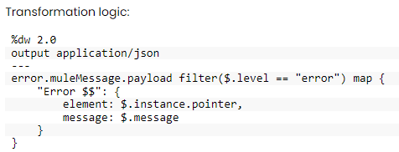

**HOW TO REMOVE INDENTATION IN JSON?**

it’s a good practice to compress the JSON response when it’s returned to any web browser or mobile application. This will reduce the size of the JSON and become easy to transfer the JSON content.

You can use **indent = false** in the header section.

**XML to JSON with name space:**

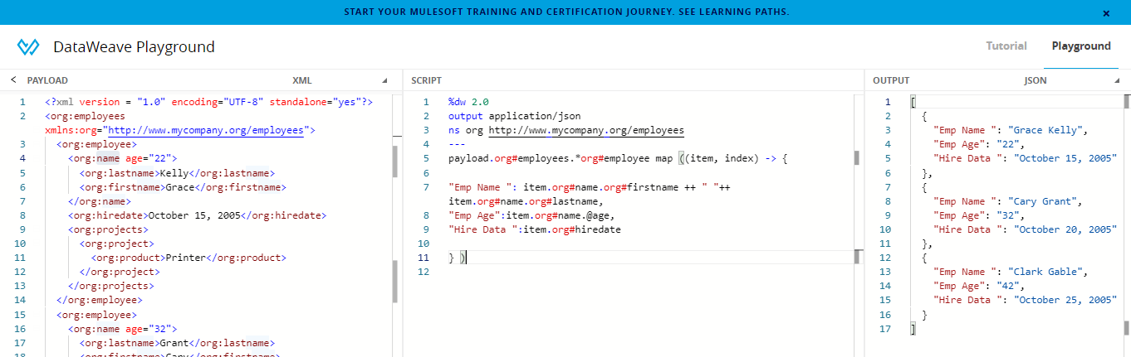

**XML to JSON with out name space:**

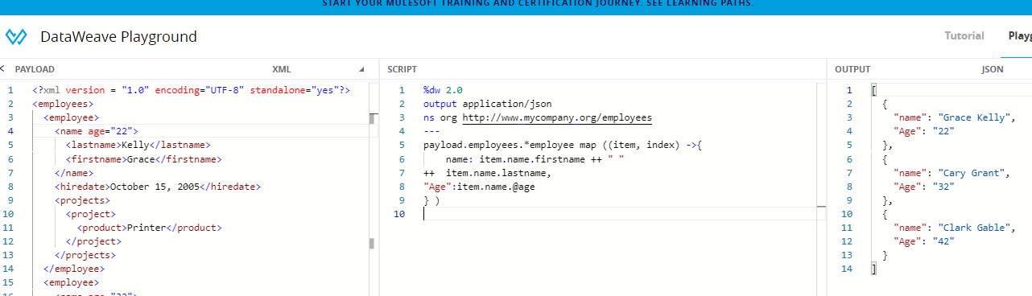

**How to find dependents:**

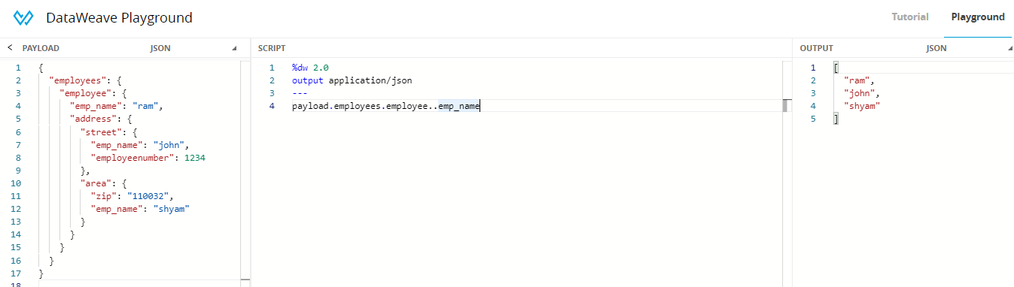

**Filter:**

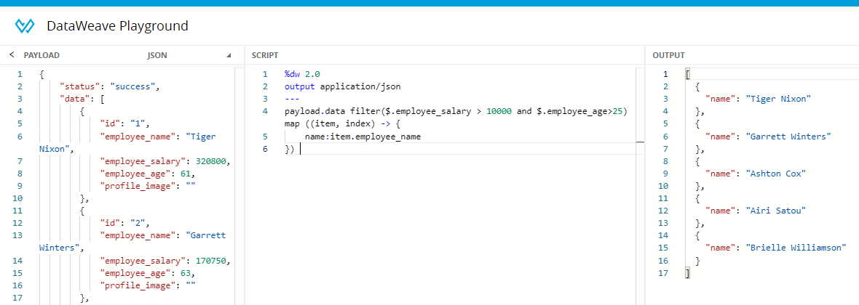

**How to enable streaming?**

**For Processing large data files we can enable Streaming.**

There are below configuration that we need to perform to enable streaming

1. **Streaming property:** To read source data as stream
2. **Deferred property:** To pass the output stream to message processor
3. We can enable streaming with setting outputMimeType with datasource which can be a listener, File Listener, FTP listener

1 Million records will get process 31 sec if we are not using Treaming .

If we use Streaming then 11 sec it will take

Set Streaming=true

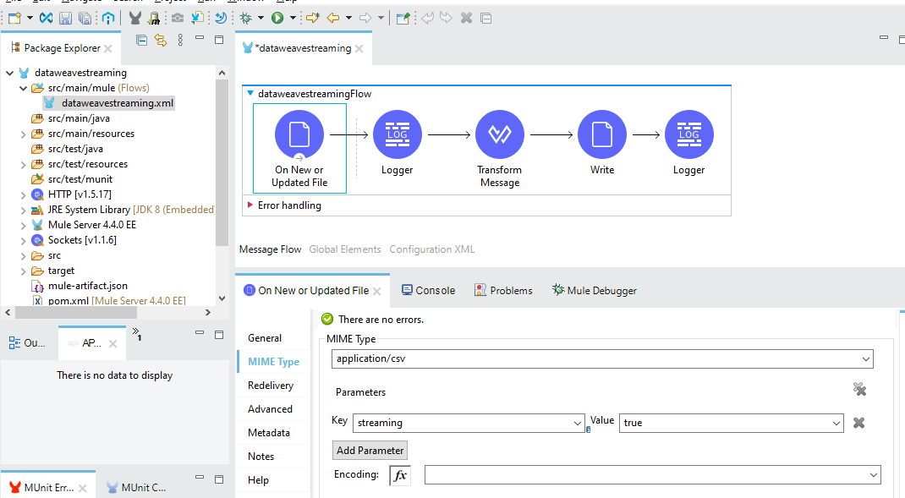

Differed = true

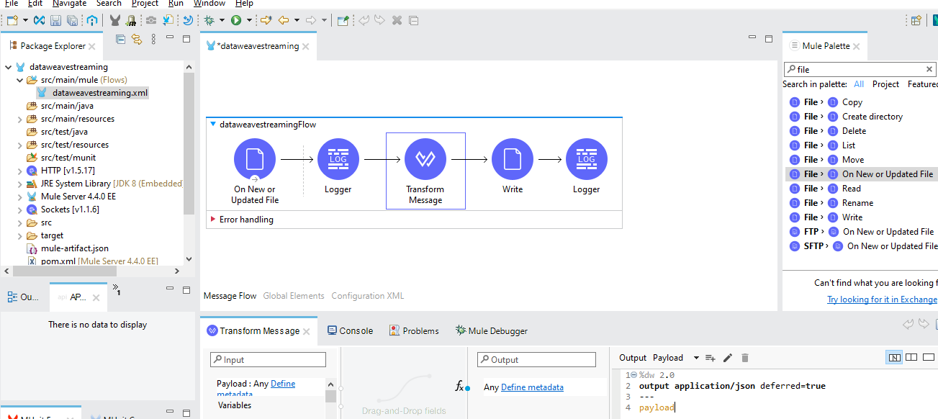

### **How to Configure the Auto Generate Keys Fields in the Insert Operation?**

The **Insert** operation outputs a Statement Result object that contains two fields: an affectedRows integer that indicates how many rows were affected by the query, and a generatedKeys map that contains the autogenerated keys.

In the following example, the output shows that the generatedKeys map is empty, although a row is successfully added to the table. The map is empty because this information is disabled by default to avoid overhead.

{

"affectedRows": 1,

"generatedKeys": {

}

}

To activate the information and generate keys, follow the next steps:

1. In your Studio flow, select the **Insert** operation.
2. In the **Advanced** tab, set the **Auto generate keys** field to **True**.

The following screenshot shows the configuration in Studio:

